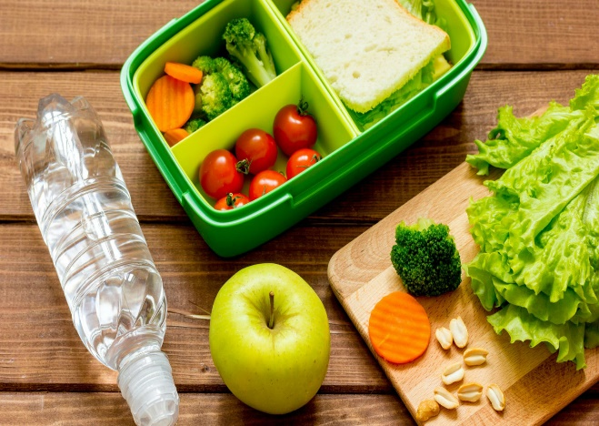
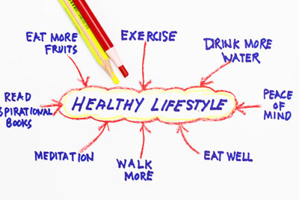

Healthy Lifestyles
Workbook

1
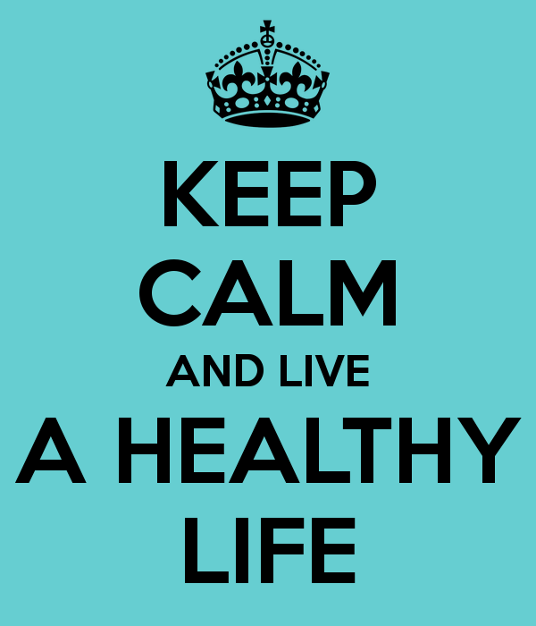
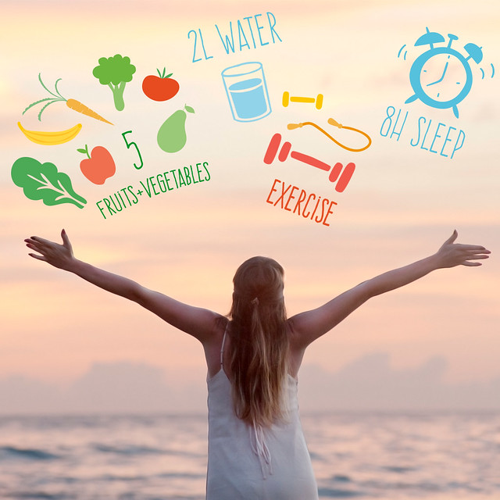

Healthy Eating
Can you unscramble the names of the different food groups?

___
afts
pironte

rinalsem

hcdaotraerby

misitavn

erawt and bfrie
although not classed as food groups are also very important.
Which group of foods:

helps our bodies to grow and repairs damage

gives us energy

and protect us from disease and help our body systems to function
keeps us warm

helps our digestive system to function properly

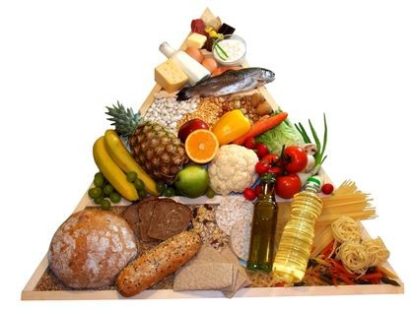
hydrates our bodies and is vital for life

A balanced diet – the eatwell plate

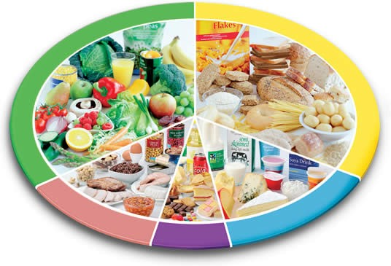

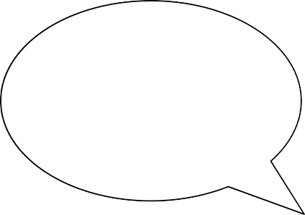
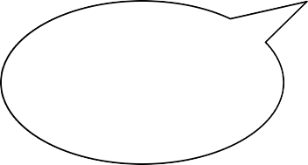
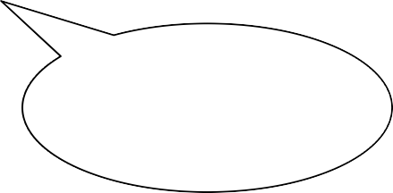
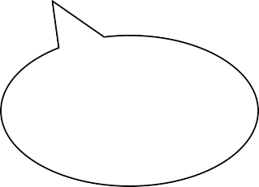
Write the food groups main nutrient in the bubble

Odd one out?

Think about the food groups to which each food belongs to decide which one is the odd one out.

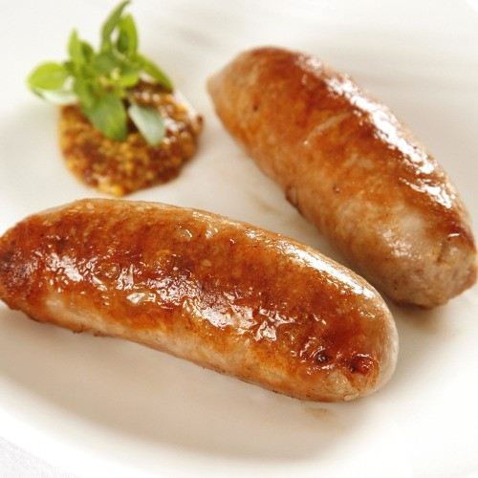

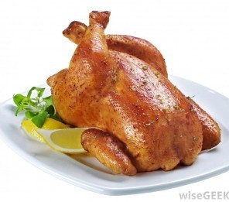
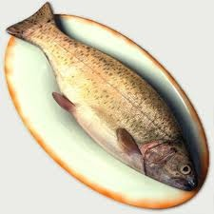

Why?

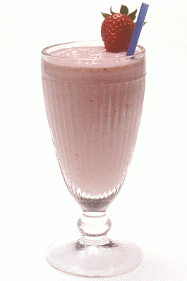
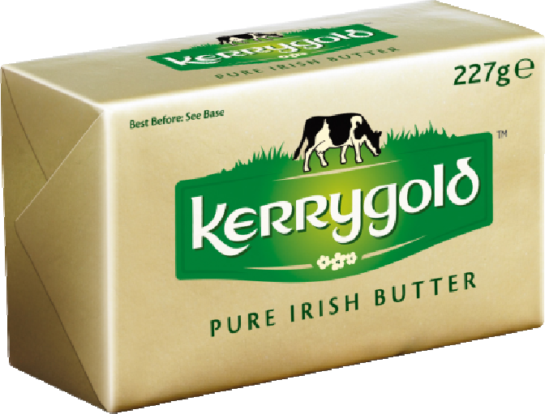
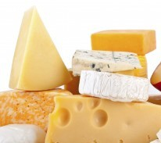

Why?

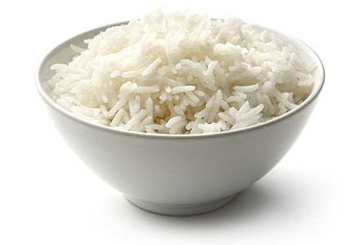
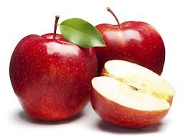
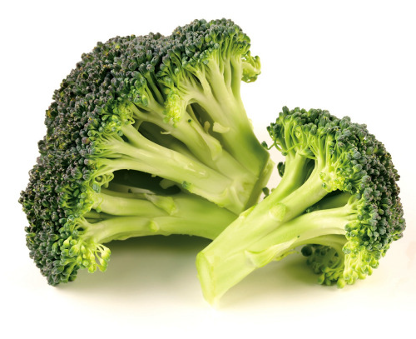
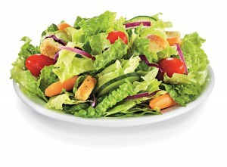
Why?

Proteins are needed in a balanced diet for ....

A | energy release
B | heat insulation
C | energy storage
D | growth and repair

Carbohydrates are needed in a balanced diet for ....

A | bone structure
B | muscle growth
C | mineral intake
D | energy supply

Fats are needed in a balanced diet for ....

A | growth of muscles
B | tissue repair
C | energy and bone structure
D | energy and heat insulation

For growth and repair of the body a person must eat ....

A | carbohydrates
B | Minerals
C | proteins
D | vitamins

Which of the following do you think are important for a healthy lifestyle?

balanced diet large house regular exercise money
intellectual stimulation holidays abroad
rest and sleep owing a car recreation education
social interaction

Other factors that affect health are alcohol, tobacco and other drugs. You need to understand the effect of these substances on physical, intellectual, emotional and social health.

Effects | Alcohol | Tobacco | Cannabis
Physical
Intellectual
Emotional
Social



 | Stress | Depression
Strategies to help prevent or manage these problems.

How can stress and depression be prevented or managed?

Is there anything that can be done?

Create a poster to promote ‘A Healthy Lifestyle’

