Georgia O’Keeffe 1887-1986
Cool facts
art@stmatthias
Georgia Totto O’Keeffe was born on 15th November 1887 in Wisconsin, USA.
She was one of seven children, and her mother encouraged Georgia’s interest in art.
The landscape in Wisconsin was very important to Georgia, which became evident in her later work.
She studied at the Art Institute of Chicago and had her first gallery show in 1916.
Georgia began experimenting with painting close up views of flowers. She used oil paints in vibrant, bold colours.
Painting the flowers at such a close range makes the viewer see the object in a completely different way.

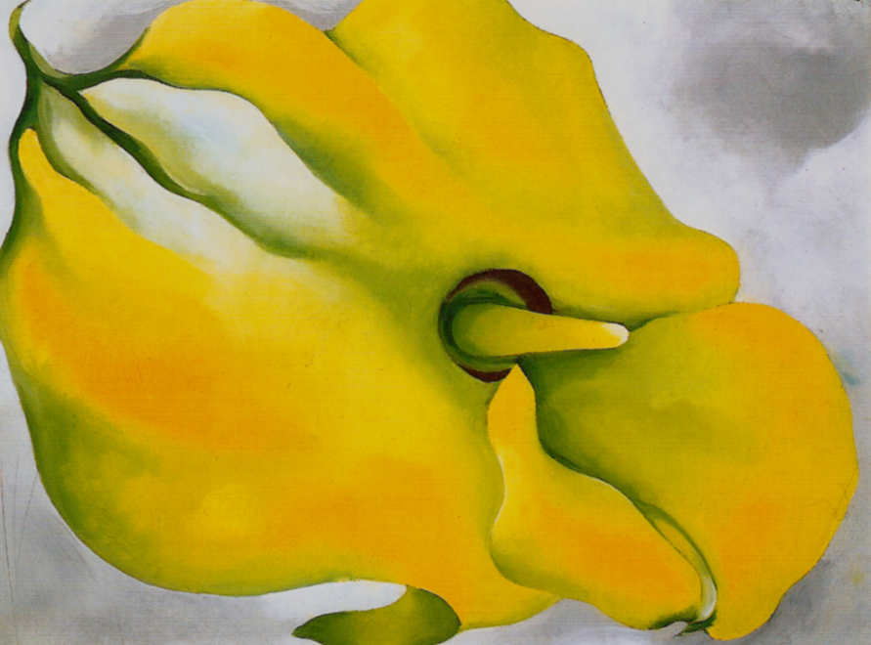
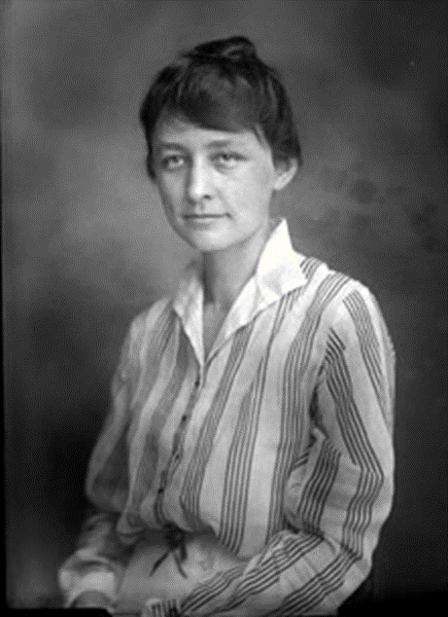
"If I could paint the flower exactly as I see it no one would see what I see because I would paint it small like the flower is small. So I said to myself - I'll paint what I see - what the flower is to me but I'll paint it big and they will be surprised into taking time to look at it – I will make even busy New Yorkers take time to see what I see of flowers."

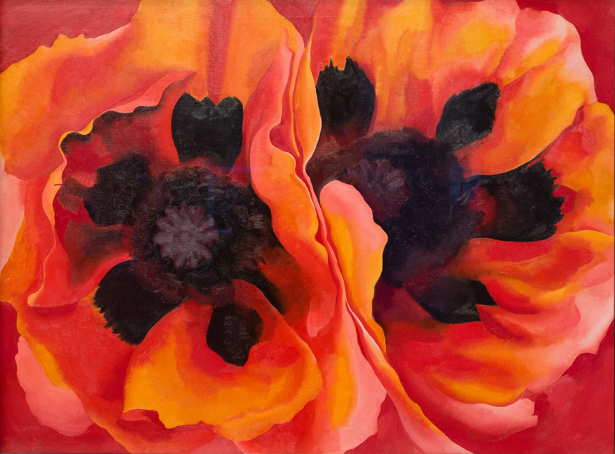
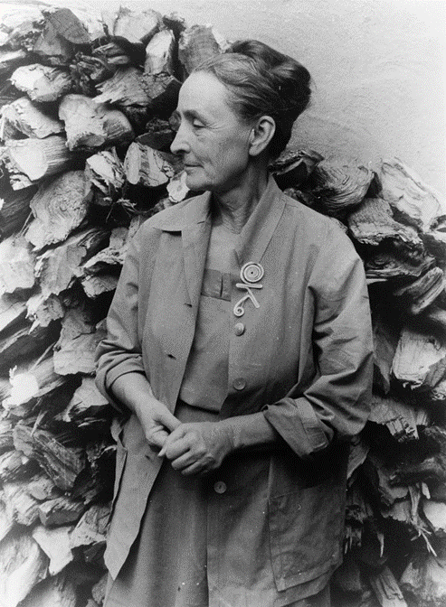
Georgia O’Keeffe began to lose her eyesight and in 1972, she painted her last unassisted painting. In 1977, at 90 years old, she said

“I can see what I want to paint. The
thing that makes you want to create
is still there.”

HER LEGACY
Georgia O’Keeffe is recognised as being a pioneer of American modernism. She was highly praised for her art, which was unusual for a woman in a male dominated art world. She died on 6th March 1986 aged 98 years old.

https://www.tate.org.uk/kids/explore/who-is/who-georgia-okeeffe

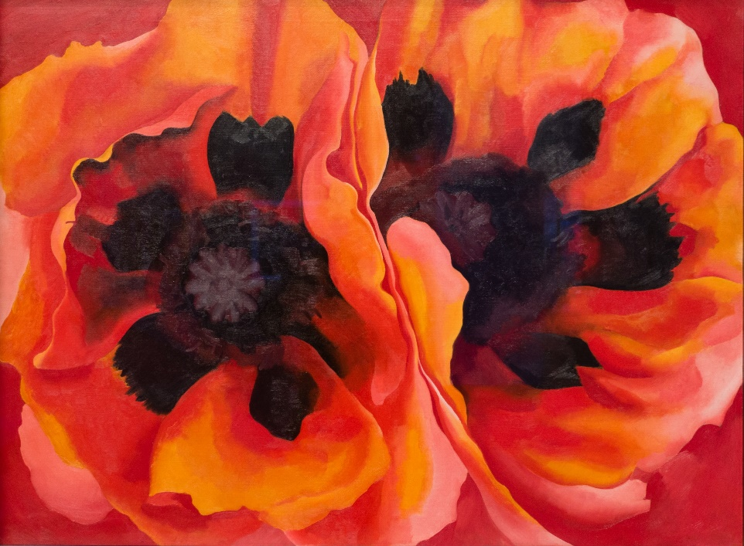
Art word bank
Vibrant close up abstract flowers warm cold natural shapes 2d 3d dark
Record some facts in this space.

Describe the artwork above using art words.

GEORGIA O’KEEFFE

Inspired by O’Keeffe, observe and draw close ups of flowers. You can draw from real life if you have flowers or use the following images.
Practical task

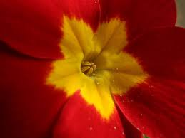
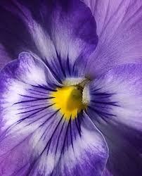
Add colour using whatever materials you have.

