English
Home Learning
Booklet



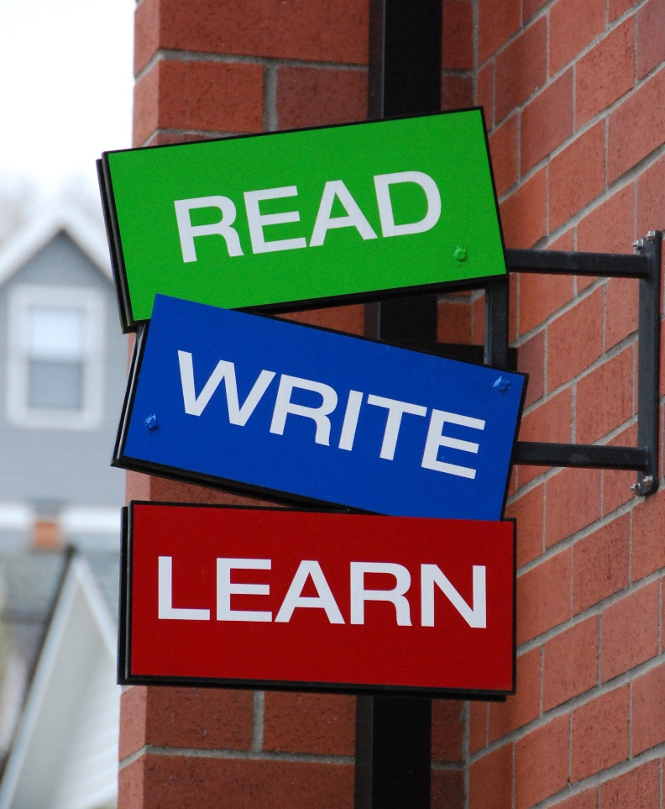

Name: ____________________

Date: ____________________

Topic 1

Alphabet - Upper and Lowercase Letters

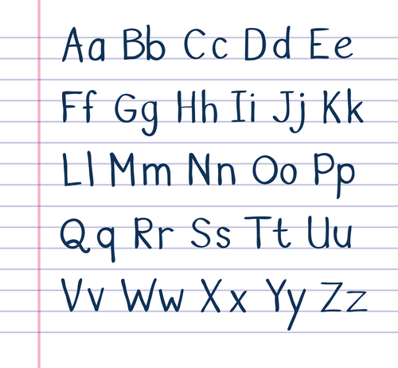

Alphabet – Upper and Lowercase
Uppercase is one of the large letters used as the first letter in writing a sentence, usually known as capital letters.
A lowercase letter is the small version; a, b, c,
Fill in the missing letters

A |  | C |  | E
F |  | H |  | J
K |  | M |  | O
P |  | R |  | T
U |  | W |  | Y
Z

Draw a line to match each uppercase letter to its lowercase letter. The first one has been done for you.

A |  | d
B |  | m
C |  | b
D |  | i
E |  | p
F |  | a
G |  | l
H |  | j
I |  | o
J |  | g
K |  | k
L |  | e
M |  | n
N |  | c
O |  | f
P |  | h

Topic 2

Using Capital Letters

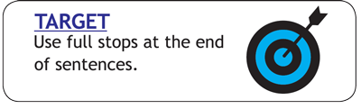

Capital letters should always be used at the beginning of a sentence and after a full stop. Capital letters are also used for people’s names, towns, street names and days of the week.



Capital letters should always be used at the beginning of a sentence and after a full stop.
A friend has written a letter. They have asked you for help. Can you find all the places they need to use a capital letter?
Circle each one -
3 Lindale Close
Addington
Ad16 3ty
Tuesday 2nd November, 2014
dear Ann,

thank you for dinner on Sunday. we hope you can come and see us when you visit Scotland in December. if you come after Christmas, i think Michelle will be here too. she would love to catch up with you before she goes back to Bolton. I hope I get a chance to speak to you on Saturday.

best wishes,

sam and lisa



Capital letters are also used for people’s names, towns, street names and days of the week.

Look at this story and circle the letters that you think needs to be a capital letter.

on monday stephen and edward were taking their pet dogs, tilly and molly, for a walk. they walked down rooney avenue and as they entered the field a strange dog ran up to them. they were not sure what to do as it looked very thin and hungry. it just stood there looking sad, so they decided to take it to their mum. she said they would look after it and they put posters up in manchester, the city where they lived.

after a couple of days a woman called at their house. Her name was mrs walker. she was very happy that they had found her dog, whose name was ben. she gave stephen and edward twenty pounds each to say thank you.

Recognise that proper nouns always have a capital letter. Proper nouns are names of people.
Write down five of your friend’s names in the box.



Proper nouns are names of places.
Write down five places you have visited.



Proper nouns are days of the week and months of the year.
Write down the month you were born and what day it is today.

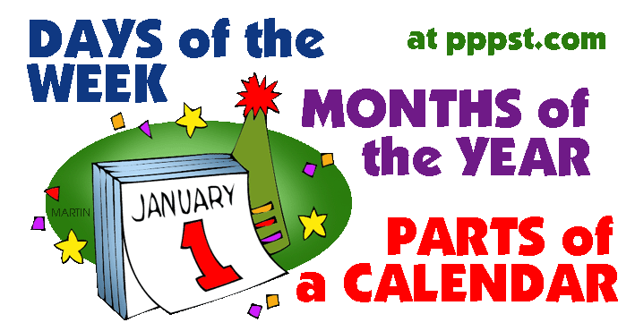

Please rewrite these sentences with the correct capital letters.

are you going to manchester today?
_______________________________________
what time is it tom?
_______________________________________
i have been to france and spain.
_______________________________________
where is lisa, we should be at the disco?
_______________________________________
mrs walker talked to the boys.
_______________________________________
i like to go shopping in bolton.
_______________________________________
my favourite food is pizza.
___________________________________
i like watching television.
_______________________________________

monday | sunday | spain | man
bolton | tree | apple | spring
tom | nice | autumn | blackburn
little | dog | city | manchester
may | rome | wednesday | peggy
town | pizza | garden | liverpool
january | gemma | summer | mother
france | father | december | country

Put a tick in each box that you think should begin with a capital letter.

Topic 3

Punctuation

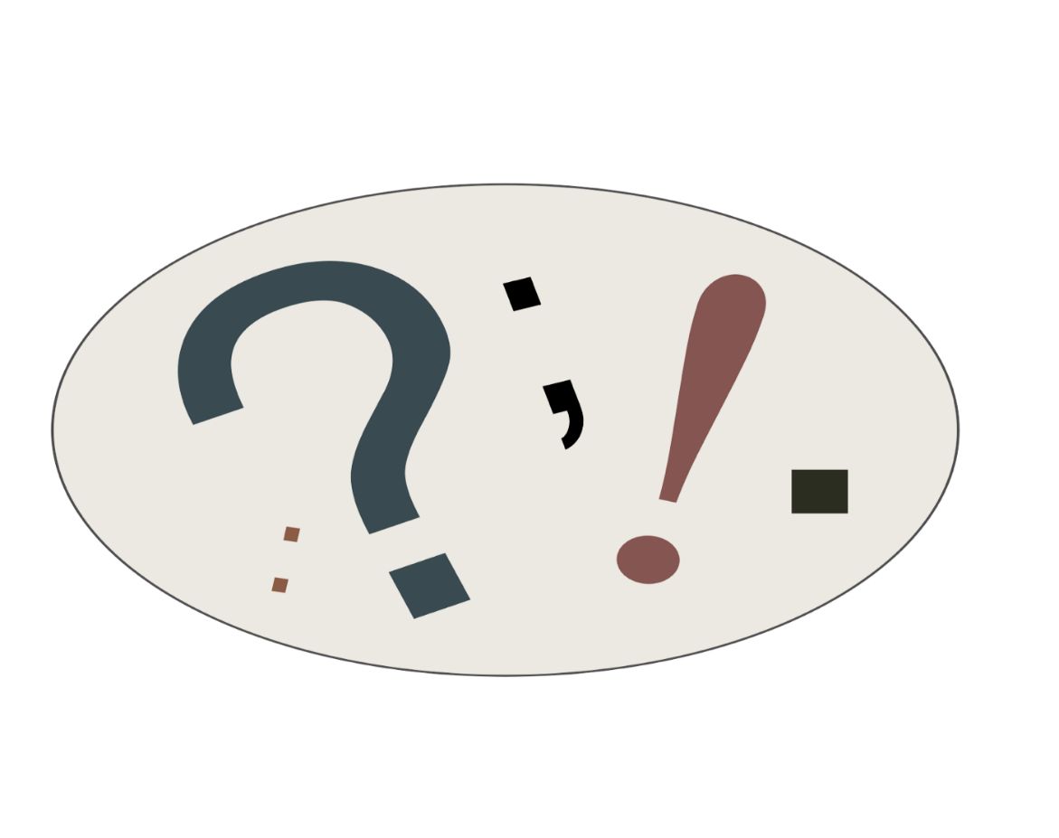

Punctuation is the marks, such as full stop, comma, exclamation mark and question mark that are all used in sentences.

Punctuation – What does it mean?

Below are some meanings of punctuation to help you with your writing.
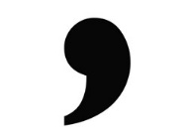
Comma
Commas are used when the reader needs to take a pause or when writing a list. E.g. I went to the shop for eggs, butter, milk and bread.

Full Stop

A full stop is used to show the end of a sentence. E.g. She went to the bank to get some money out.

Question Mark

This is used when asking a question. E.g. What time does this lesson finish?

Exclamation Mark

These are used to show commands, shock or surprise. E.g. Wow he is a really good singer!

Punctuation Match
Match the correct definition to the correct punctuation mark. The first one is done for you.

Capital Letter Used to separate a list of items. A natural pause in speech.

Full Stop . Used at the end of a command or exclamation to show feelings such as surprise, shock and excitement.

Exclamation Mark ! Used at the beginning of a sentence and also: names, places, the word I, days of the week and months.

Comma , Used to show the end of a sentence.

Question Mark ? Used to show a question.

Fill in the missing punctuation marks to finish these sentences.

- When is your birthday ___
- My sister hates football __ but I love it.
- What time does cricket finish __
- The man shouted really loudly__
- I went to the shop and bought some apples, bananas__ oranges and pears.
- Oh that really scared me__
- What time will you be in__
- I didn’t want to lose my socks__ gloves and hat.
- How are you today __
- Wow that is amazing __

Can you change these sentences to make them into questions?
1. You are going to the shop.
___________________________________
2. We are best friends.
___________________________________
3. They will go home soon.
___________________________________
4. You have got a big car.
___________________________________
5. We shall go bowling tomorrow.
___________________________________
6. We did have a great time last night.
___________________________________
7. You have bought a new pair of shoes.
___________________________________
8. I did go to school yesterday.
___________________________________

9. That is a very exciting book.
___________________________________
10. It will be Gill's birthday tomorrow.
___________________________________
Circle the exclamation marks in the sentences below.
Hooray I won the game - Hooray! I won the game!

1. I want to thank you for a great job!
2. When are we going home?
3. Thanks so much!
4. Please take out the rubbish.
5. Are you going to the game?
6. My favourite player got a goal!
7. Yay! We made it!
8. What a great job!
9. Please finish your homework.
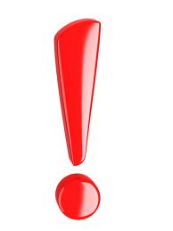
10. Did you see the football game?


Commas are missing from the sentences below. Can you add the missing punctuation to each sentence?

- Go past the white church turn left walk to the end of the street and you will see my house.
- Tom started writing his test two hours ago and he completed it by noon.
- Sara wanted to play with her friends yet the idea of completing her homework seemed more appropriate.
- I have no intention of celebrating my next birthday nor do I want you to have a party for me.
- If I could repeat year nine I would do things differently.
- As a student I always had dreams of being a famous rock star.
- Doing a maths test is not difficult if you study for them.
- By the time we got home the movie we really wanted to see was over.


