ENGLISH
Home Learning
Booklet





Name: ____________________

Date: ____________________

Topic 4

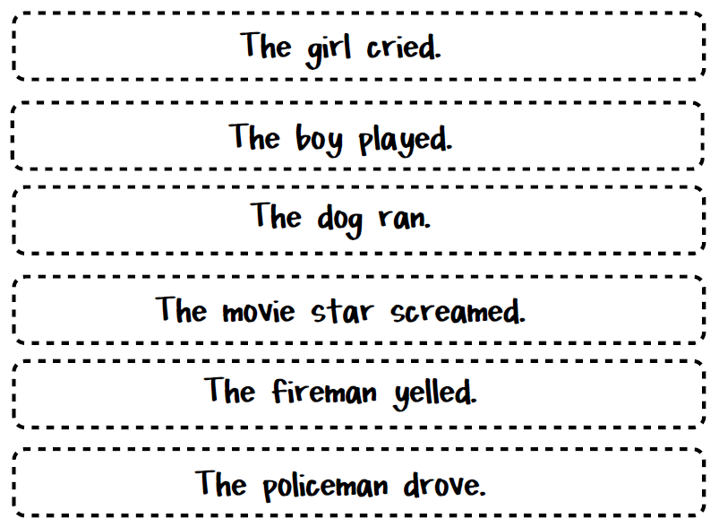
Writing Sentences

A sentence is a group of words that are put together to mean something.

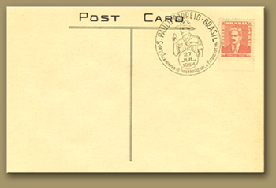
Sentences

Dear __________________  _____________________  _____________________  _____________________  _____________________  _____________________  _____________________  _____________________  _____________________ |   Mr Joe Bloggs  1 Cannon Street  Ribchester  England  RK1 6HG
You are in France, working in a hotel. Write to a friend on a postcard and tell him:
- Where you are
- What you are doing
- What 3 things you like about the country, or the job

Sentences
he | she | we | me
was | my | you | her
all | our | be | they

Write some sentences using these words. Don’t forget to put a full stop at the end of your sentence!
___________________________________________________________________________________________________________________________________________________________________________________________________________________________________________________________________________________________________________________________

Sentences continued…
some | one | said | come
do | so | were | when
have | their | out | like
children | little | what | from

Write some sentences using these words. Don’t forget to put a full stop at the end of your sentence!
___________________________________________________________________________________________________________________________________________________________________________________________________________________________________________________________________________________________________________________________

Topic 5

Reading



Reading" is the process of looking at a series of written symbols and getting meaning from them. When we read, we use our eyes to receive written symbols (letters, punctuation marks and spaces) and we use our brain to convert them into words, sentences and paragraphs that communicate something to us.


Reading - Read the text and answer the questions.

What is on TV at 7.30pm on BBC 1? _________________________________
Holby City is on Channel 5, True or False? ____________________________
What is on ITV 1 at 8.00pm? ______________________________________
What time is World’s on? ________________________________________
Can you watch Ultimate Bikers on BBC 1? _____________________________
Is Sherlock on Channel 4? ________________________________________
What time is Restoration Man on and what channel? _____________________
Coronation Street is on Channel 4, True or False? ______________________

Reading

Amanda lives in Newcastle and goes to London to see her sister. She goes by train. At the station she buys a return ticket. It takes 3 hours from Newcastle to London.
Answer these questions about the story above, and circle the one you think is right:

1) Why does Amanda go to London?
a) To see her brother
b) To see her sister
c) To see her friend

2) How does Amanda travel to London?
a) By bus
b) By car
c) By train

3) How many hours is it to London?
a) 1 hour
b) 2 hours
c) 3 hours

4) What ticket does Amanda buy?
a) Return
b) Single


Reading

Lesson | Start time | End time
Maths | 3 o’clock | 4 o’clock
English | 2 o’clock | 5 o’clock
I.T. | 1 o’clock | 3 o’clock
P.E. | 2 o’clock | 3 o’clock

- Which lesson starts at 1 o’clock? ____________________
- Which lesson finishes at 5 o’clock? ___________________
- How many lesson start at 2 o’clock? Tick the correct answer.
1 lesson
2 lessons
3 lessons

- Which lesson finishes at the same time as the I.T lesson? Tick the correct answer.

Maths
P.E.
Complete the word search
P | L | P | T | L | B | N | E | P | X | D | C | W | O | L | Z
E | A | M | H | K | E | M | U | A | Y | R | J | O | G | I | G
E | U | U | I | N | A | A | I | R | S | I | A | V | X | S | T
L | G | J | N | V | L | E | R | L | B | V | M | N | J | T | A
S | H | X | K | O | P | J | P | N | C | E | G | C | U | E | R
C | R | R | O | W | A | L | K | S | V | K | N | R | L | N | J
B | F | K | C | Q | U | M | T | D | Z | G | I | Y | Y | L | O
Z | J | M | T | U | D | Z | D | L | Y | D | S | J | F | Z | Q
U | E | H | G | Q | Z | D | Z | U | P | L | I | S | U | I | F
U | P | Y | I | X | W | G | J | I | H | S | F | D | C | J | Z
Z | R | G | S | A | M | O | L | L | A | U | T | T | A | L | K
U | X | F | W | Y | Q | W | R | R | N | W | L | E | E | A | T
P | D | F | Z | I | C | B | P | H | I | T | R | K | A | D | V
B | M | I | H | U | G | K | D | C | T | B | D | S | H | L | A
CLIMB | CRY | DRIVE
EAT | FLY | JOG
JUMP | LAUGH | LEARN
LISTEN | LOOK | RUN
SING | SLEEP | SPEAK
STEAL | TALK | THINK
THROW | WALK

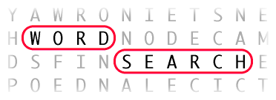

Here is an example of a library card.


Address

Phone Phone

Date of Birth Mobile
Email

jbloggs@supermail.com
07896345213
01204 768798
12 Bright Street
Bolton
Lancs
BL8 7RT

12/06/1984
Name: Joe Bloggs Bolton Library

Using the following details fill in the library cards like the one above on the next page.
Leanne Smith lives at 34 North Road, Bolton, BL8 7GD. Her email address is l.smith@googlemail.com. Her phone number is 01203 678987 and her mobile number is 07865234765. She was born on 23rd October 1976.
Marcus Jones lives at 276 Whittle Street, Bolton, BL8 3HG. His email address is Marcus.jones@firmail.co.uk. His phone number is 01204567543 and his mobile number is 07564231876. He was born on 5th July 2000.

Name: Bolton Library

Address

Phone

Date of Birth Mobile
Email



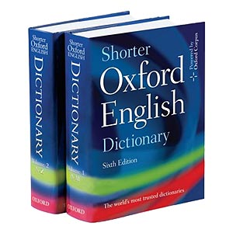
Using a dictionary, find out the meaning of these words and write them down.

Address

Phone

Mobile

Date of Birth Email

Name: Bolton Library

Noun _________________________________________________________________________________________________________________________________________________________

Verb _________________________________________________________________________________________________________________________________________________________

Sentence _________________________________________________________________________________________________________________________________________________________

Comma _________________________________________________________________________________________________________________________________________________________

Punctuation _________________________________________________________________________________________________________________________________________________________

From everything you have learnt within this booklet, write a text message in the mobile phone text box:




