Fractions, Decimals and Percentages

GCSE MATHS
Name: Teacher:

Learning objectives

By the end this pack you will be able to:

–Convert between Fractions, Decimals and Percentages
- Simplify fractions

FRACTIONS | GRADES : F,E,D

FRACTION – DECIMAL MATCH

Pair up the fractions and decimals from the grid.

0.1 | 1  2 | 0.25 | 0.67 | 2  5
0.2 | 3  10 | 0.3 | 1  3 | 0.75
2  3 | 7  10 | 1  5 | 0.4 | 3  4
0.33 | 1  4 | 0.5 | 1  10 | 0.7

CONVERTING DECIMALS

Change each decimal to a fraction and write it in its’ simplest form

1. | 0.3 | 2. | 0.8 | 3. | 0.12 | 4. | 0.15 | 5. | 0.9
6. | 0.35 | 7. | 0.24 | 8. | 0.04 | 9. | 0.124 | 10. | 0.125

CONVERTING FRACTIONS

1. Use a calculator to change each fraction to a decimal. Write down the full calculator display.

3 5
a) b)

8 12
4 7
c) d)

25 9
3 9 17
e) f) g)

20 16 40

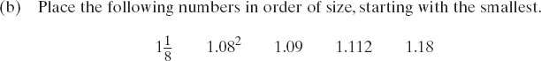

EXAM QUESTIONS

1.

2.

FRACTIONS | GRADES : G,F
EQUIVALENT FRACTIONS
- Write down five fractions that are equivalent to:
a) ¼ b) ⅛ c) ⅜ d) ¾

- Fill in the missing numbers:

1 1 5

2 10 2

a) = b)

2 10
= c)

3
= d)

3
=

7 21

e) 2 = f)

10 1
g)
=

15 3
h)
=

12 = 1

5 20 30 20 24

SIMPLIFYING FRACTIONS
Write each fraction in its’ simplest form.

3 8 9
1. 2. 3.

9 40 12
12 15
4. 5.

18 35

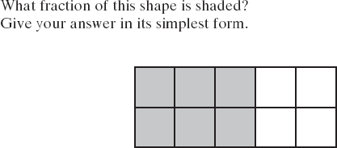
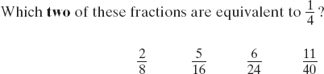

ORDERING FRACTIONS

- Copy the questions and circle the fraction that is the largest?
a) | 1 | or | 1 | b) | 1 | or | 1 | c) | 1 | or | 2
 | 3 |  | 4 |  | 3 |  | 6 |  | 3 |  | 7
d) | 1 | or | 1 | e) | 5 | or | 3 | f) | 6 | or | 7
 | 2 |  | 3 |  | 8 |  | 4 |  | 7 |  | 9
g) | 1 | or | 1 | h) | 2 | or | 3 | i) | 4 | or | 2
 | 2 |  | 5 |  | 7 |  | 8 |  | 6 |  | 5

- Write each list in order from smallest to biggest.
a) | 1 | , | 1 | , | 1 | , | 1 | e) | 1 | , | 1 | , | 1 | , | 1
 | 4 |  | 8 |  | 10 |  | 5 |  | 8 |  | 5 |  | 2 |  | 10
b) | 1 | , | 1 | , | 1 | , | 1 | f) | 3 | , | 1 | , | 2 | , | 9
 | 3 |  | 2 |  | 8 |  | 4 |  | 8 |  | 5 |  | 4 |  | 10
d) | 1 | , | 1 | , | 1 | , | 1 | h) | 2 | , | 1 | , | 2 | , | 2
 | 2 |  | 10 |  | 3 |  | 5 |  | 7 |  | 5 |  | 3 |  | 9
f) | 3 | , | 1 | , | 2 | , | 9 | j) | 2 | , | 1 | , | 3 | , | 3 | , | 2
 | 8 |  | 5 |  | 4 |  | 10 |  | 7 |  | 4 |  | 9 |  | 8 |  | 5

EXAM QUESTION
1. 2.

FRACTIONS | GRADES : E,D
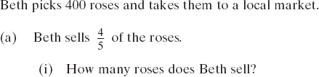
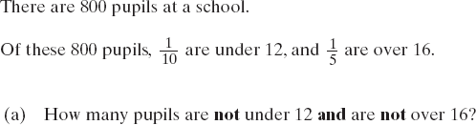
FRACTIONS OF AMOUNTS

Work out all these fractions of 60
1/2
1/3
1/4
2/4
1/6


1/12
3/12
6/12
2/6
1/10
2/10
5/10
1/5
2/5

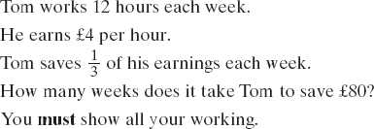
EXAM QUESTIONS
3/6
4/10
4/12
2/12

1.
2.
3.
4.
5.

FRACTIONS | GRADES : D,C

ADDING AND SUBTRACTING FRACTIONS

Fill in the boxes by adding the fractions.
+ | 1  3 | 2  5 | 3  8 | 2  7
1

2
2

3

- Work out each question without a calculator. Show your working and write your answer in its’ simplest form.

a) 1 + b)
3

4 5
3 − c)

5 3
1
1 + d)

9 10
1
3 − 1
4 6

- Work out each question with a calculator.

a) 3 + 3 b)

4 15
7 − 2 c)

10 3
7 + 7 d)

9 10
13 − 9
15 20

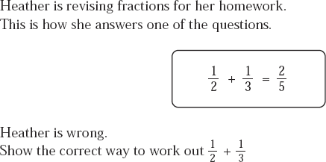
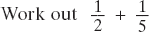
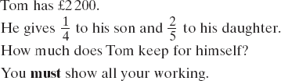
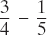

EXAM QUESTIONS

1.
2.
3.
4.
5.
6.
7.

FRACTIONS | GRADES : D,C
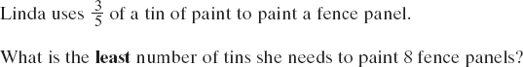
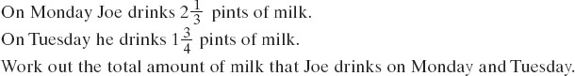
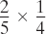
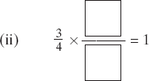
x | 1  3 | 2  5 | 3  8 | 2  7
1
2
2
3

MULTIPLYING FRACTIONS

Fill in the boxes by multiplying the fractions.
MIXED NUMBERS

1 3 2 1 2 1
1. 1 + 2 2. 3 −1 3. 2 × 3
2 5 5 2 3 4
DIVIDING WITH FRACTIONS

1 1 2 1 3 3 3 1 7 3
1. ÷ 2. ÷ 3. ÷ 4. ÷ 5. ÷
2 4 5 10 4 8 10 5 9 4
EXAM QUESTIONS 1.
2.
3.
,
4.
5.
6.
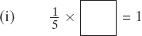
7.
,

PERCENTAGES | GRADES : F, E
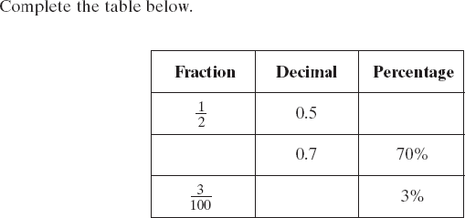
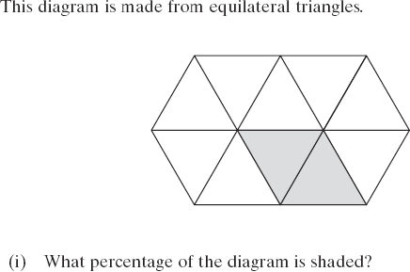
FRACTIONS, DECIMALS AND PERCENTAGES

- Copy and complete the table.
Fraction | Percentage | Decimal
4

10
 | 10%
2

5
 |  | 0.80
 | 25%
3

20
 | 20%
 |  | 0.10
 | 5%
1

4
 |  | 0.05

- Change each fraction to a percentage:
 | 1 |  | 7 |  | 9 |  | 3
a) | 2 | b) | 10 | c) | 20 | d) | 4

- Change each decimal to a fraction:
a) 0.4 b) 0.9 c) 0.35 d) 0.65
- Change each percentage to a fraction:
a) 60% b) 15% c) 12% d) 32%

EXAM QUESTIONS
1 2
. .

PERCENTAGES | GRADES : F, E
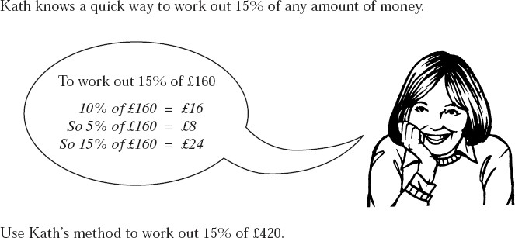
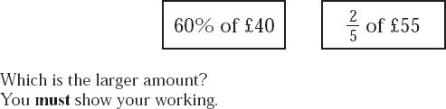
PERCENTAGES OF AMOUNTS

 | 300 | 220 | 140 | 260 | 360 | 500 | 800 | 90 | 130
5%
10%
15%
20%
25%
30%
40%
45%
50%
60%
70%
90%

WHAT PERCENTAGE?

1. What percentage of 50 is 5? 2. What percentage of 20 is 8?
3. What percentage of 90 is 27? 4. What percentage of 70 is 35?
5. What percentage of 80 is 48? 6. What percentage of 60 is 42?

EXAM QUESTIONS

1.
2.
3.
4.

PERCENTAGES | GRADES : D,C
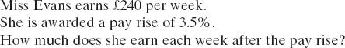
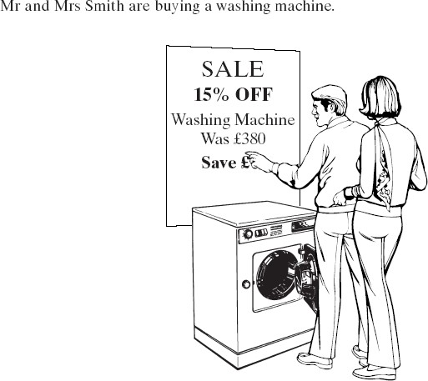
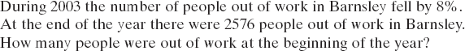
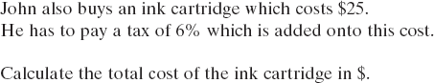
PERCENTAGE INCREASE AND DECREASE

1. Increase £90 by 10% 2. Increase £110 by 50%

3. Increase £120 by 5% 4. Decrease £40 by 20%

5. Decrease £700 by 30% 6. Decrease £320 by 5%

7. Increase £620 by 25% 8. Decrease £180 by 60% EXAM QUESTIONS
1.
2.
How much do they pay for the washing machine?
3.
4.

