English


Working from home week 5

Comprehension – Non-Fiction

Stephen King is a successful horror, suspense and fantasy writer, who has written books such as It, the Dark Tower trilogy, Carrie, The Shining and Pet Sematary.
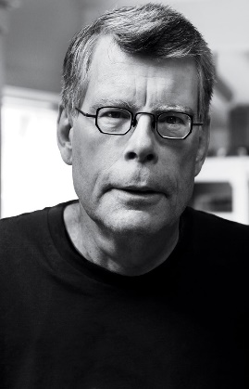
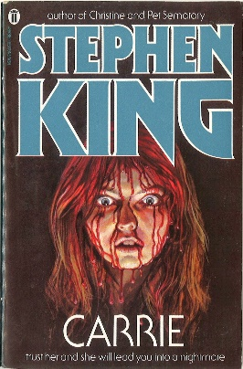
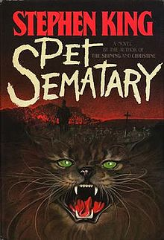
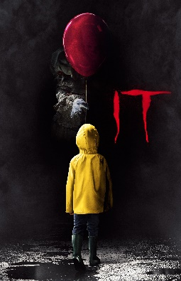
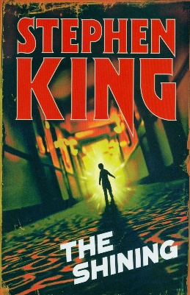

Read the extract and answer the questions at the end

Extract from Stephen King’s On Writing

If you want to be a writer, you must do two things above all others: read a lot and write a lot. There's no way around these two things that I'm aware of, no shortcut.
I'm a slow reader, but I usually get through seventy or eighty books a year, mostly fiction. I don't read in order to study the craft; I read because I like to read. It's what I do at night, kicked back in my blue chair. Similarly, I don't read fiction to study the art of fiction, but simply because I like stories. Yet there is a learning process going on. Every book you pick up has its own lesson or lessons, and quite often the bad books have more to teach than the good ones.
When I was in the eighth grade, I happened upon a paperback novel by Murray Leinster, a science fiction pulp writer who did most of his work during the forties and fifties, when magazines like Amazing Stories paid a penny a word. I had read other books by Mr. Leinster, enough to know that the quality of his writing was uneven. This particular tale, which was about mining in the asteroid belt, was one of his less successful efforts. Only that's too kind. It was terrible, actually, a story populated by paper-thin characters and driven by outlandish plot developments. Worst of all (or so it seemed to me at the time), Leinster had fallen in love with the word zestful.

Characters watched the approach of ore-bearing asteroids with zestful smiles. Characters sat down to supper aboard their mining ship with zestful anticipation. Near the end of the book, the hero swept the blonde heroine into a zestful embrace. For me, it was the literary equivalent of a smallpox vaccination: I have never, so far as I know, used the word zestful in a novel or a story. God willing, I never will.

Good writing, on the other hand, teaches the learning writer about style, graceful narration, plot development, the creation of believable characters, and truth-telling. A novel like The Grapes of Wrath may fill a new writer with feelings of despair and good old-fashioned jealousy -- "I'll never be able to write anything that good, not if I live to be a thousand" -- but such feelings can also serve as a spur, goading the writer to work harder and aim higher. Being swept away by a combination of great story and great writing -- of being flattened, in fact -- is part of every writer's necessary formation. You cannot hope to sweep someone else away by the force of your writing until it has been done to you.

- What two things does King say you have to do to be a good writer?

…………………………………………………………………………………………………………………………………….

…………………………………………………………………………………………………………………………………….

- What is the author’s opinion on bad books?

…………………………………………………………………………………………………………………………………….

…………………………………………………………………………………………………………………………………….

…………………………………………………………………………………………………………………………………….

- Why has the author never used the word ‘zestful’ in his writing?

…………………………………………………………………………………………………………………………………….

…………………………………………………………………………………………………………………………………….

…………………………………………………………………………………………………………………………………….

- What are the five ingredients for a good story?

…………………………………………………………………………………………………………………………………….

…………………………………………………………………………………………………………………………………….

…………………………………………………………………………………………………………………………………….

…………………………………………………………………………………………………………………………………….

…………………………………………………………………………………………………………………………………….

- What does the author say about feeling jealous?

…………………………………………………………………………………………………………………………………….

…………………………………………………………………………………………………………………………………….

- Find an example of a metaphor and explain it.

…………………………………………………………………………………………………………………………………….

…………………………………………………………………………………………………………………………………….

…………………………………………………………………………………………………………………………………….

…………………………………………………………………………………………………………………………………….

- What does the author say is important if you want to be a good writer? Make sure to include evidence in your answer.

…………………………………………………………………………………………………………………………………….

…………………………………………………………………………………………………………………………………….

…………………………………………………………………………………………………………………………………….

…………………………………………………………………………………………………………………………………….

…………………………………………………………………………………………………………………………………….

…………………………………………………………………………………………………………………………………….

- If you could, what question would you like to ask Stephen King?

…………………………………………………………………………………………………………………………………….

…………………………………………………………………………………………………………………………………….

Comprehension – Poetry

Read the poem and answer the questions at the end

London

By William Blake

I wander thro' each charter'd street,
Near where the charter'd Thames does flow.
And mark in every face I meet
Marks of weakness, marks of woe.

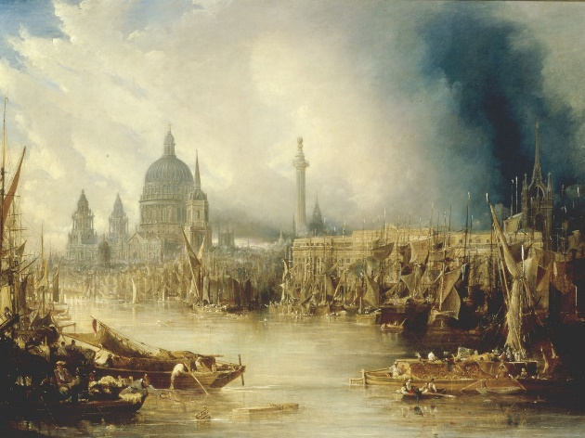
In every cry of every Man,
In every Infants cry of fear,
In every voice: in every ban,
The mind-forg'd manacles I hear

How the Chimney-sweepers cry
Every blackning Church appalls,
And the hapless Soldiers sigh
Runs in blood down Palace walls

But most thro' midnight streets I hear
How the youthful Harlots curse
Blasts the new-born Infants tear
And blights with plagues the Marriage hearse

Glossary

Mind-forg’d: made in our minds Manacles: chains and cuffs to restrain someone
Blights: spoils or damages Charter’d: can either mean ‘controlled’ or ‘mapped’

- In the first stanza (verse), what impression do we get of the people who live in London?

…………………………………………………………………………………………………………………………………….

…………………………………………………………………………………………………………………………………….

- What meanings could the word ‘marks’ have?

…………………………………………………………………………………………………………………………………….

…………………………………………………………………………………………………………………………………….

…………………………………………………………………………………………………………………………………….

- Hearses are used in funerals. Why has Blake used a hearse to describe marriage?

…………………………………………………………………………………………………………………………………….

…………………………………………………………………………………………………………………………………….

- Can you find an example of personification (when something not human is given human qualities)?

…………………………………………………………………………………………………………………………………….

…………………………………………………………………………………………………………………………………….

- Is there an image that you find particularly powerful in the poem? Give a reason why.

…………………………………………………………………………………………………………………………………….

…………………………………………………………………………………………………………………………………….

- What do you think Blake means when he writes that the soldier’s sigh ‘runs in blood down palace walls’?

…………………………………………………………………………………………………………………………………….

…………………………………………………………………………………………………………………………………….

- Would you like to live in this London? Why/why not?

…………………………………………………………………………………………………………………………………….

…………………………………………………………………………………………………………………………………….

- What does Blake mean when he writes ‘mind-forg’d manacles’? See the glossary for help!

…………………………………………………………………………………………………………………………………….

…………………………………………………………………………………………………………………………………….

…………………………………………………………………………………………………………………………………….

…………………………………………………………………………………………………………………………………….

……………………………………………………………………………………………………………………………………

- What does ‘hapless’ mean?

…………………………………………………………………………………………………………………………………….

…………………………………………………………………………………………………………………………………….

- If you could ask Blake one question, what would it be?

…………………………………………………………………………………………………………………………………….

…………………………………………………………………………………………………………………………………….

Creative Response to a Picture


Task: Imagine you are in this picture.

Make sure to:
- Describe what you can see, touch, taste, hear, smell
- Use as many language features as possible (similes, metaphors, personification, etc.)

………………………………………………………………………………………………………………………………………………….

………………………………………………………………………………………………………………………………………………….

………………………………………………………………………………………………………………………………………………….

………………………………………………………………………………………………………………………………………………….

………………………………………………………………………………………………………………………………………………….

………………………………………………………………………………………………………………………………………………….

………………………………………………………………………………………………………………………………………………….

………………………………………………………………………………………………………………………………………………….

………………………………………………………………………………………………………………………………………………….

………………………………………………………………………………………………………………………………………………….

………………………………………………………………………………………………………………………………………………….

………………………………………………………………………………………………………………………………………………….

………………………………………………………………………………………………………………………………………………….

………………………………………………………………………………………………………………………………………………….

………………………………………………………………………………………………………………………………………………….

………………………………………………………………………………………………………………………………………………….

………………………………………………………………………………………………………………………………………………….

………………………………………………………………………………………………………………………………………………….

………………………………………………………………………………………………………………………………………………….

………………………………………………………………………………………………………………………………………………….

………………………………………………………………………………………………………………………………………………….

………………………………………………………………………………………………………………………………………………….

………………………………………………………………………………………………………………………………………………….

………………………………………………………………………………………………………………………………………………….

………………………………………………………………………………………………………………………………………………….



………………………………………………………………………………………………………………………………………………….

………………………………………………………………………………………………………………………………………………….

………………………………………………………………………………………………………………………………………………….

………………………………………………………………………………………………………………………………………………….

………………………………………………………………………………………………………………………………………………….

………………………………………………………………………………………………………………………………………………….

………………………………………………………………………………………………………………………………………………….

………………………………………………………………………………………………………………………………………………….

………………………………………………………………………………………………………………………………………………….

………………………………………………………………………………………………………………………………………………….

………………………………………………………………………………………………………………………………………………….

………………………………………………………………………………………………………………………………………………….

………………………………………………………………………………………………………………………………………………….

………………………………………………………………………………………………………………………………………………….

………………………………………………………………………………………………………………………………………………….

………………………………………………………………………………………………………………………………………………….

………………………………………………………………………………………………………………………………………………….

………………………………………………………………………………………………………………………………………………….

………………………………………………………………………………………………………………………………………………….

Create a Newspaper

Task: Write a newspaper report based on this picture.
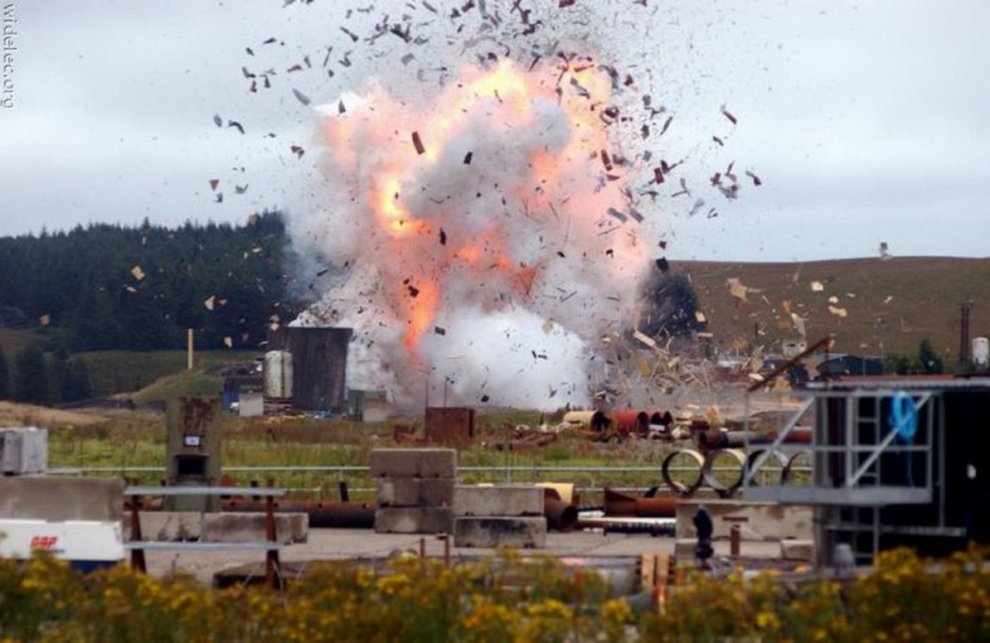

Make sure to include:

- A catchy headline
- The 5 Ws (what happened, where it happened, when it happened, who was there, why it happened)
- A quote from a witness who was there or a person discovering it when they came to work
- The nice-to-knows (what happened next, what is being done, what advice police are giving)
The Daily News

Price Date:

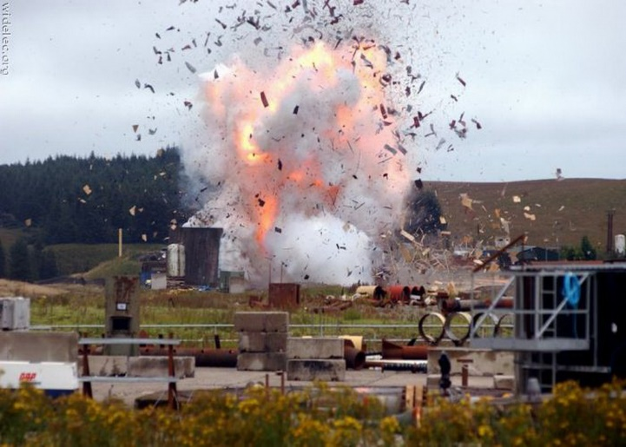

……………………………………………….

……………………………………………….

……………………………………………….

……………………………………………….

……………………………………………….

……………………………………………….

……………………………………………….

……………………………………………….

……………………………………………….

……………………………………………….

……………………………………………….

……………………………………………….

……………………………………………….

……………………………………………….

……………………………………………….

……………………………………………….

……………………………………………….

……………………………………………….

……………………………………………….

……………………………………………….

……………………………………………….

……………………………………………….

……………………………………………….

……………………………………………….

……………………………………………….

……………………………………………….

……………………………………………….

……………………………………………….

……………………………………………….

……………………………………………….

……………………………………………….

……………………………………………….

English Wordsearch
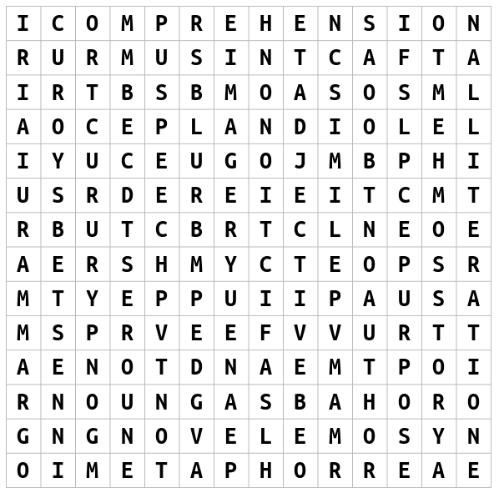
WORDS: Imagery Speech
Suspense Comprehension Metaphor
Grammar Alliteration Author
Story Simile Blurb
Adjective Tone Fact
Fiction Adverb Purpose
Novel Noun Poem

Design a Book Cover

Make sure to include the author name, title and make it bright and colourful! It can be an alternative cover for an existing book or better yet, make your own one up!

Design a Bookmark
Make sure it is bright and colourful. You could base it on your favourite book or superhero!

Create Your Own Comic

