Maths Revision Work Book
Tasks, Activities, Ideas

Week 5

Week 5: Day 1

Arithmetic
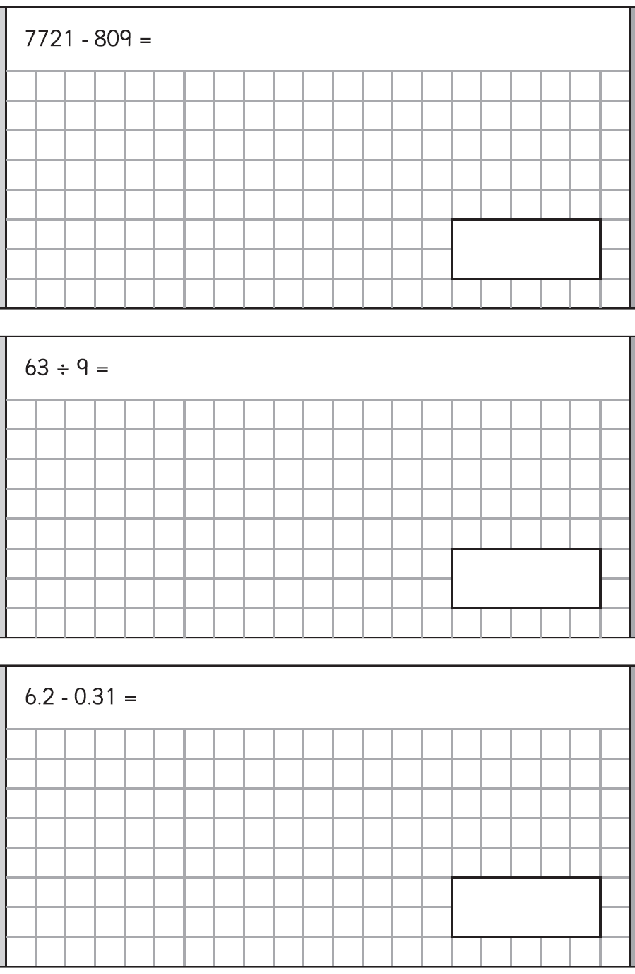

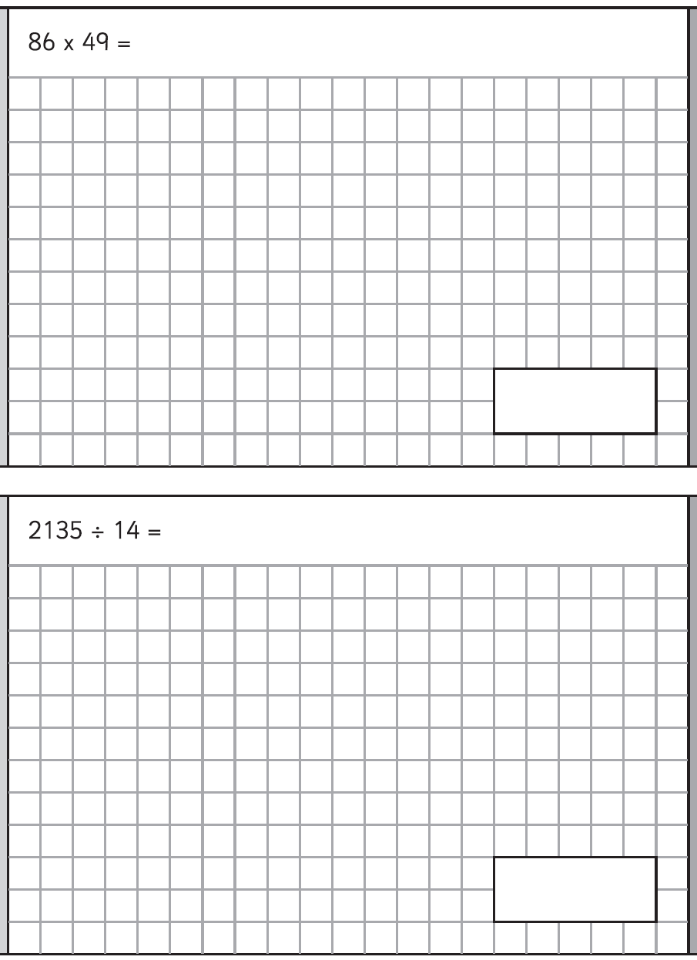

Week 5: Day 2

Reasoning Questions

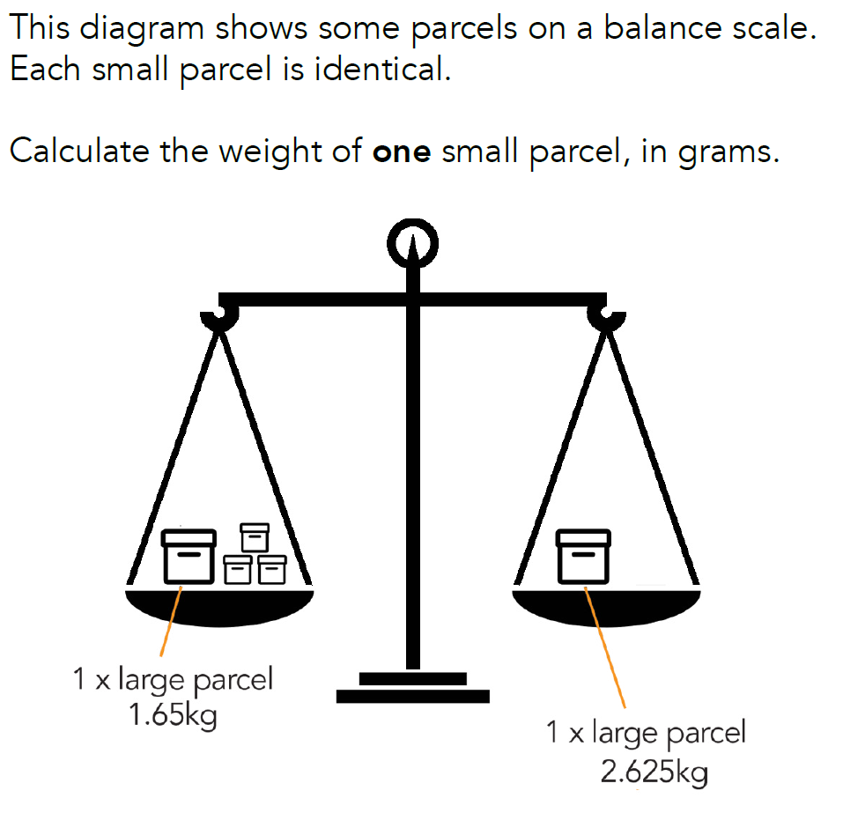

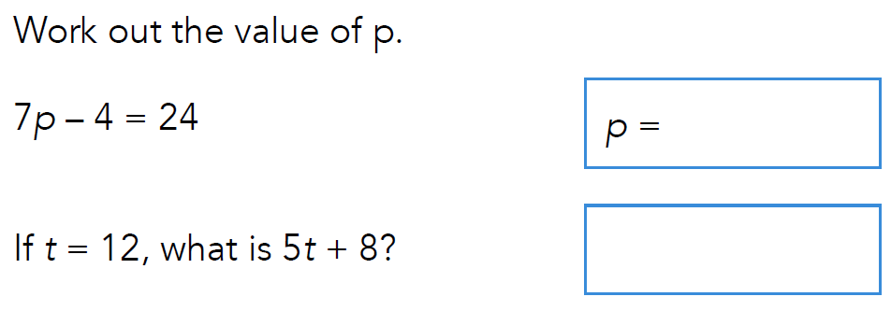

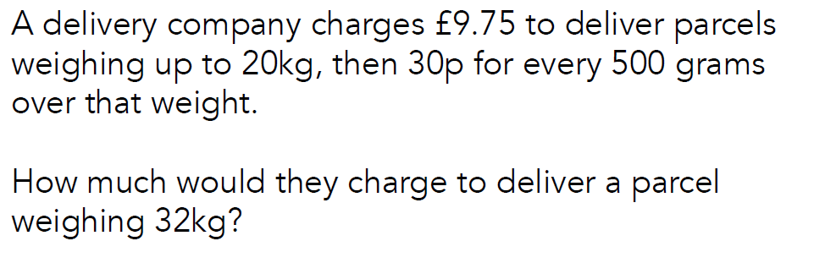

Week 5: Day 3
Quick Question Strips

Prime Numbers/Factors | Rounding

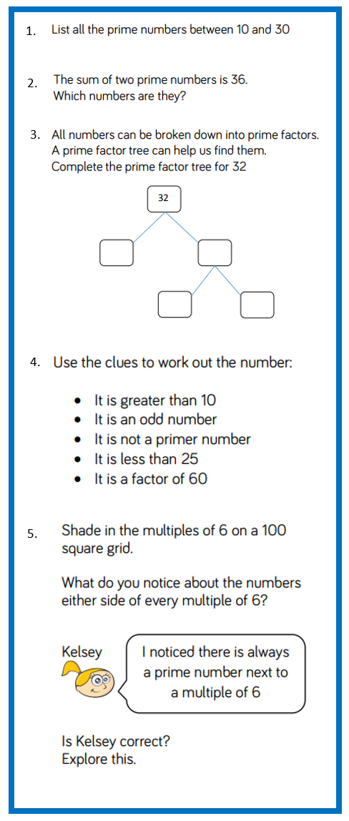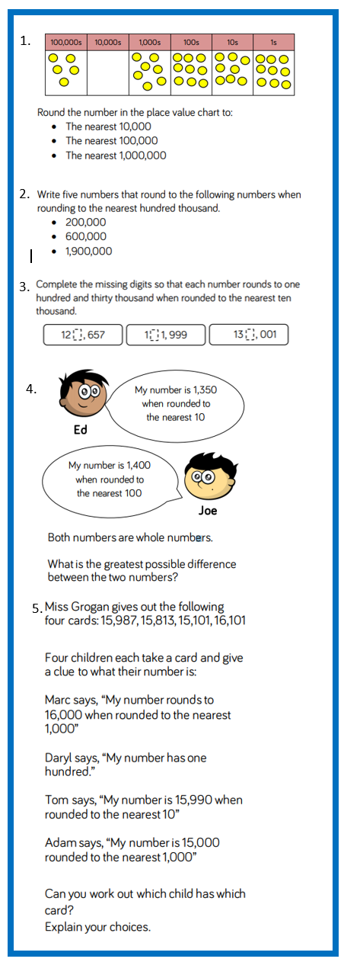

Week 5: Day 4

Question Board
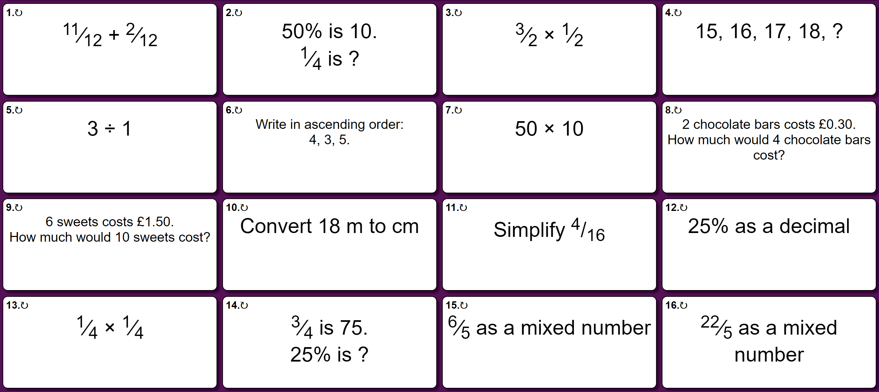
Get the stop-watch out! How many did you complete in 7 minutes?
Which questions did you get wrong or not have a go at? Is there something you can do to help you learn these?

Week 5: Day 5

Worded Problems: Volume



