English
Working from home week 6


Comprehension – Non-Fiction

Read the extract and answer the questions at the end

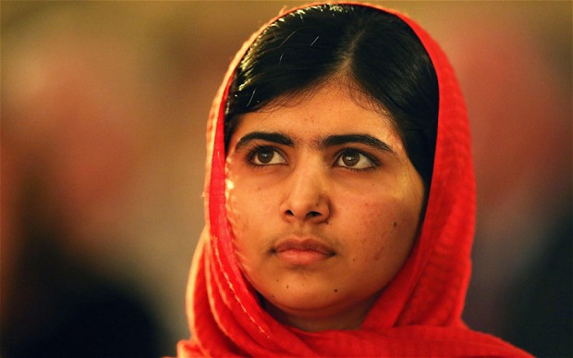
Malala Yousufzai is an activist who was shot by the Taliban on her way to school because she spoke out against girls being banned from being educated. She survived and continues to speak out about the importance of female rights.
'I Am Malala': Excerpt of the Prologue
The ride to school was quick, just five minutes up the road and along the river. I arrived on time, and exam day passed as it always did. The chaos of Mingora city surrounded us with its honking horns and factory noises while we worked silently, bent over our papers in hushed concentration.
By day’s end I was tired but happy; I knew I’d done well on my test. “Let’s stay on for the second trip,” said Moniba, my best friend. “That way we can chat a little longer.” We always liked to stay on for the late pickup.
For days I’d had a strange, gnawing feeling that something bad was going to happen. One night I’d found myself wondering about death. What is being dead really like? I wanted to know. I was alone in my room, so I turned toward Mecca and asked God. “What happens when you die?” I said. “How would it feel?”
If I died, I wanted to be able to tell people what it felt like. “Malala, you silly girl,” I said to myself then, “you’d be dead and you couldn’t tell people what it was like.”
Before I went to bed, I asked God for one more thing. Can I die a little bit and come back, so I can tell people about it?
But the next day had dawned bright and sunny, and so had the next one and the one after that. And now I knew I’d done well on my exam. Whatever cloud had been hanging over my head had begun to clear away. So Moniba and I did what we always did: We had a good gossip. What face cream was she using? Had one of the male teachers gone for a baldness cure? And, now that the first exam was over, how difficult would the next one be?
When our bus was called, we ran down the steps. As usual, Moniba and the other girls covered their heads and faces before we stepped outside the gate and got into the waiting dyna, the white truck that was our Khushal School “bus.” And, as usual, our driver was ready with a magic trick to amuse us. That day, he made a pebble disappear. No matter how hard we tried, we couldn’t figure out his secret.
We piled inside, twenty girls and two teachers crammed into the three rows of benches stretching down the length of the dyna. It was hot and sticky, and there were no windows, just a yellowed plastic sheet that flapped against the side as we bounced along Mingora’s crowded rush-hour streets.
Just after we passed the Little Giants snack factory and the bend in the road not more than three minutes from my house, the van slowed to a halt. It was oddly quiet outside. “It’s so calm today,” I said to Moniba. “Where are all the people?”
I don’t remember anything after that, but here’s the story that’s been told to me: Two young men in white robes stepped in front of our truck.
“Is this the Khushal School bus?” one of them asked.
The driver laughed. The name of the school was painted in black letters on the side.
The other young man jumped onto the tailboard and leaned into the back, where we were all sitting.
“Who is Malala?” he asked.
No one said a word, but a few girls looked in my direction.
He raised his arm and pointed at me. Some of the girls screamed, and I squeezed Moniba’s hand.
Who is Malala? I am Malala, and this is my story.

- What word is used to describe Mingora in the second sentence?

…………………………………………………………………………………………………………………………………….

…………………………………………………………………………………………………………………………………….

- Use three words to describe Malala’s personality?

…………………………………………………………………………………………………………………………………….

…………………………………………………………………………………………………………………………………….

- How was she feeling when she got on the bus?

…………………………………………………………………………………………………………………………………….

…………………………………………………………………………………………………………………………………….

- What had been in her thoughts for days?

…………………………………………………………………………………………………………………………………….

…………………………………………………………………………………………………………………………………….

- What does she say to her friend that makes us think something bad might happen?

…………………………………………………………………………………………………………………………………….

…………………………………………………………………………………………………………………………………….

- How did the shooter know which girl Malala was?

…………………………………………………………………………………………………………………………………….

…………………………………………………………………………………………………………………………………….

- Imagine you were Malala’s friend next to her on the bus. How would you be feeling?

…………………………………………………………………………………………………………………………………….

…………………………………………………………………………………………………………………………………….

…………………………………………………………………………………………………………………………………….

…………………………………………………………………………………………………………………………………….

…………………………………………………………………………………………………………………………………….

…………………………………………………………………………………………………………………………………….

- If you could, what question would you like to ask Malala?

…………………………………………………………………………………………………………………………………….

…………………………………………………………………………………………………………………………………….

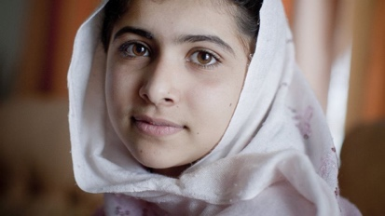

Comprehension – Poetry

Read the poem and answer the questions at the end

The Eagle
Alfred Lord Tennyson

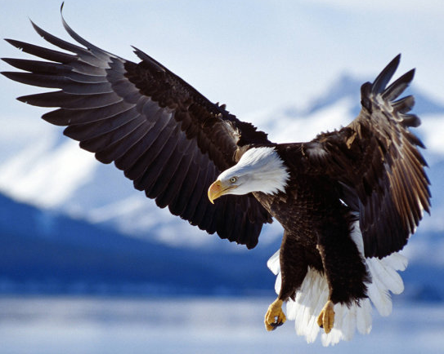
He clasps the crag with crooked hands;
Close to the sun in lonely lands,
Ring’d with the azure world, he stands.

The wrinkled sea beneath him crawls;
He watches from his mountain walls,
And like a thunderbolt he falls.

Clasps: holds tightly Azure: bright blue

- What is the eagle doing in the first stanza (verse)?

…………………………………………………………………………………………………………………………………….

…………………………………………………………………………………………………………………………………….

- How does this change?

…………………………………………………………………………………………………………………………………….

…………………………………………………………………………………………………………………………………….

- Can you find a simile?

…………………………………………………………………………………………………………………………………….

…………………………………………………………………………………………………………………………………….

- Can you find an example of personification (when something not human is given human qualities)?

…………………………………………………………………………………………………………………………………….

…………………………………………………………………………………………………………………………………….

- Is there an image that you find powerful in the poem? Give a reason why.

…………………………………………………………………………………………………………………………………….

…………………………………………………………………………………………………………………………………….

- Where is the eagle?

…………………………………………………………………………………………………………………………………….

…………………………………………………………………………………………………………………………………….

- What does the poem give you a sense of?

…………………………………………………………………………………………………………………………………….

…………………………………………………………………………………………………………………………………….

- Describe the eagle in three words.

…………………………………………………………………………………………………………………………………….

…………………………………………………………………………………………………………………………………….
Creative Response to a Picture


Task: Imagine you are in this picture.

Describe:
- What you can see, hear, smell, touch and taste.
- Why you are there
- How you are feeling
- What is happening that you can’t see in the picture.

………………………………………………………………………………………………………………………………………………….

………………………………………………………………………………………………………………………………………………….

………………………………………………………………………………………………………………………………………………….

………………………………………………………………………………………………………………………………………………….

………………………………………………………………………………………………………………………………………………….

………………………………………………………………………………………………………………………………………………….

………………………………………………………………………………………………………………………………………………….

………………………………………………………………………………………………………………………………………………….

………………………………………………………………………………………………………………………………………………….

………………………………………………………………………………………………………………………………………………….

………………………………………………………………………………………………………………………………………………….

………………………………………………………………………………………………………………………………………………….

………………………………………………………………………………………………………………………………………………….

………………………………………………………………………………………………………………………………………………….

………………………………………………………………………………………………………………………………………………….

………………………………………………………………………………………………………………………………………………….

………………………………………………………………………………………………………………………………………………….

………………………………………………………………………………………………………………………………………………….

………………………………………………………………………………………………………………………………………………….

………………………………………………………………………………………………………………………………………………….

………………………………………………………………………………………………………………………………………………….

………………………………………………………………………………………………………………………………………………….

………………………………………………………………………………………………………………………………………………….

………………………………………………………………………………………………………………………………………………….

………………………………………………………………………………………………………………………………………………….


Create a Newspaper

Task: Write a newspaper report based on this picture.

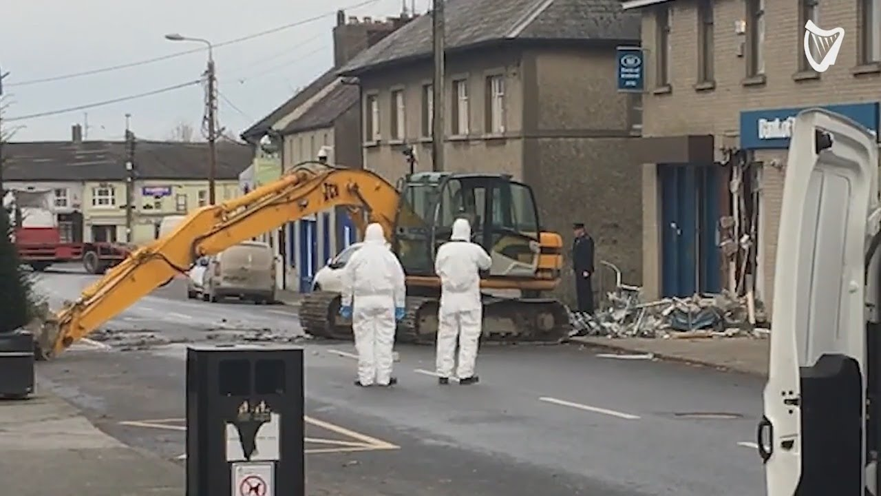

Make sure to include:

- A catchy headline
- The 5 Ws (what happened, where it happened, when it happened, who was there, why it happened)
- A quote from a witness who was there or a person discovering it when they came to work
- The nice-to-knows (what happened next, what is being done, what advice police are giving)
The Daily News

Price Date:

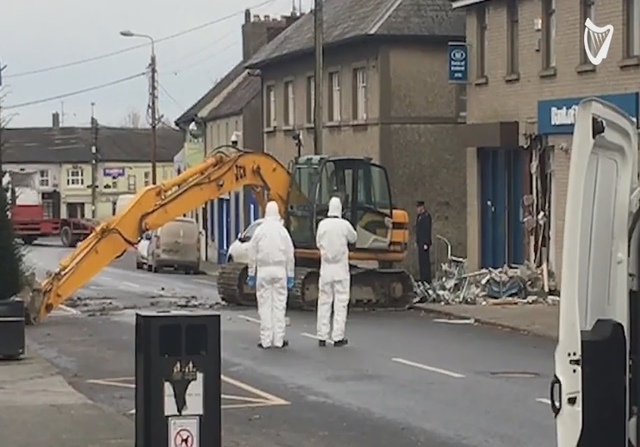

……………………………………………….

……………………………………………….

……………………………………………….

……………………………………………….

……………………………………………….

……………………………………………….

……………………………………………….

……………………………………………….

……………………………………………….

……………………………………………….

……………………………………………….

……………………………………………….

……………………………………………….

……………………………………………….

……………………………………………….

……………………………………………….

……………………………………………….

……………………………………………….

……………………………………………….

……………………………………………….

……………………………………………….

……………………………………………….

……………………………………………….

……………………………………………….

……………………………………………….

……………………………………………….

……………………………………………….

……………………………………………….

……………………………………………….

……………………………………………….

……………………………………………….

……………………………………………….

English Wordsearch
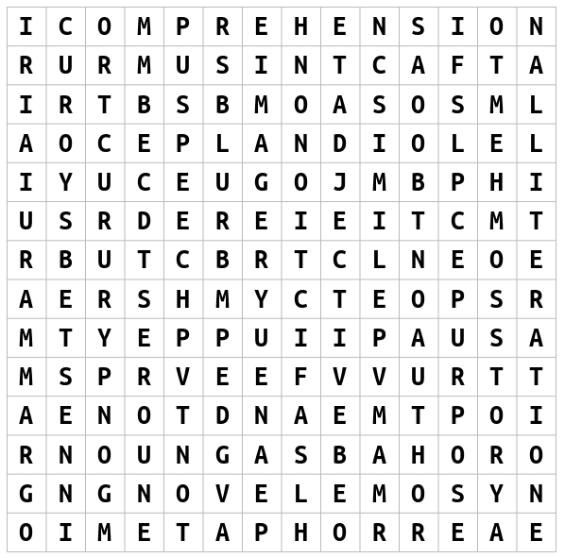
WORDS: Imagery Speech
Suspense Comprehension Metaphor
Grammar Alliteration Author
Story Simile Blurb
Adjective Tone Fact
Fiction Adverb Purpose
Novel Noun Poem

Design a Book Cover

Make sure to include the author name, title and make it bright and colourful! It can be an alternative cover for an existing book or better yet, make your own one up!

Design a Bookmark
Make sure it is bright and colourful. You could base it on your favourite book or superhero!

Create Your Own Comic

