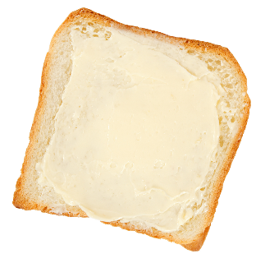
1) £10.54 – £6.99 | 2) 18 × 0.5 | 3) Write down 20% as a decimal, in its simplest form.
4) 8² | 5) 10% of £84 | 6) 177 ÷ 3
7) What is the area of a rectangle measuring 5cm by 7cm? | 8) 1.4 × 9 | 9) 2 + 7 × 3

Name:
Bread & Butter

Reasoning

Rhys is arranging a raffle for a
school fair. The tickets cost
50p each.
The main prize of the raffle is
£20. The second prize is £5.
How much profit will Rhys make if he manages to sell 140 tickets?
1) 248 – 120 – 36 | 2) Write down $\frac{3}{10}$ as a percentage. | 3) £45.23 – £20.45
4) Which number is two less than one million? | 5) What is 285 cm in metres? | 6) 7 × ___ = 2 × 28
7) Estimate the cost of buying six books costing £11.99 each. | 8) What time is 53 minutes after 07:46? | 9) Which number is half way between –7 and 9?

Bread & Butter

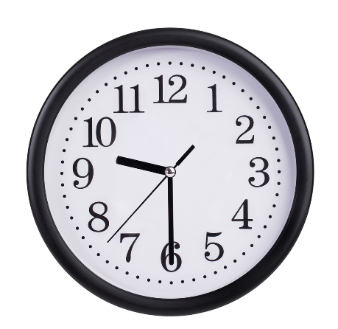

Reasoning

If it is 3pm in London, then it is
2am (the next day) in Sydney,
Australia. Christine lives in
Sydney and wishes to phone her
sister in London, when it is
9:30am in London. What time (in Sydney) should Christine phone her sister?

1) 10% of £60 | 2) 874 – 249 | 3) 5.4 × 8
4) 12 – 8 ÷ 2 | 5) $\sqrt{81}+\sqrt{4}$ | 6) What is the mean of the numbers 2, 11, 8?
7) Which is greater: $\frac{4}{5}$ or 70%? | 8) 2.5 – 1.37 | 9) What is the perimeter of a rectangle measuring 8cm by 2cm?

Bread & Butter

Jane’s Café
Tea £1.40
Coffee £1.55
Apple Juice
£0.90
Orange Juice £0.85
Water £0.70

Reasoning

The drinks menu of Jane’s Café is
shown on the right.
Tomos and his family go the
café and order 2 coffees, 3 teas
and 4 orange juices. How much
change will Tomos receive from
a £20 note?

1) 276 + 787 | 2) £5 – £1.35 | 3) Write down a quarter of a million in figures.
4) 380 ÷ ___ = 19 | 5) What is 3.4 kg in grams? | 6) Write down 26% as a decimal.
7) Calculate 30% of £75. | 8) The square root of a number is 9. What is that number? | 9) Which day is five days before October 3rd?

Bread & Butter

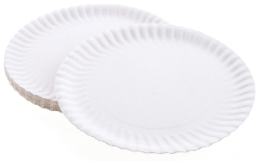

Reasoning

Elsi wants to buy 225 paper plates
for a big party. Three local shops
sell paper plates:
SHOP 1 SHOP 2 SHOP 3
20 for 35p 50 for 90p 25 for 49p
From which shop should Elsi buy the plates?

1) 823 – 284 | 2) Write down all the factors of 20. | 3) Write down half of four hundred thousand in figures.
4) £120 – £21.99 | 5) 0.16 + _____ = 1 | 6) 7 × 2 + 4 × 2
7) Round off 3.791 to one decimal place. | 8) How many minutes are there in $3\frac{1}{4}$ hours? | 9) 2 ÷ 0.2

