The Slave Trade
Home Learning Booklet
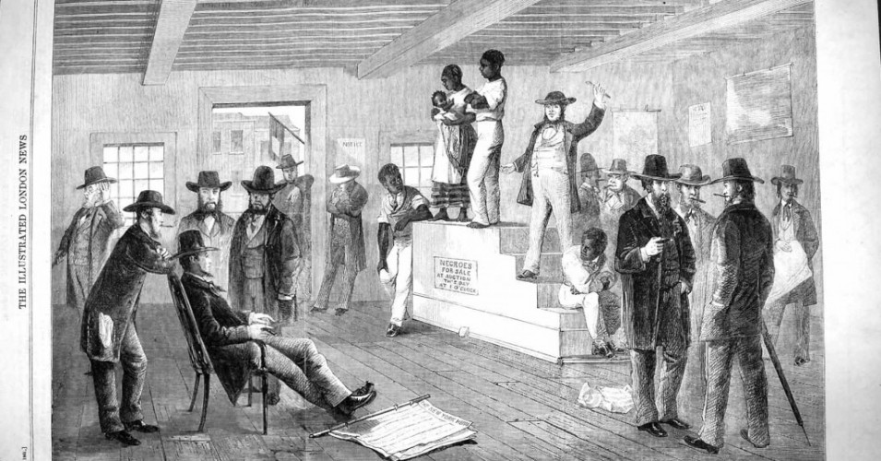
Please complete all tasks as fully as possible

Part One
What were the main events during the slave trade period?
Learning outcome: to place events into the correct chronological order.
Chronological= placing events into order of time from earliest to latest. This is an important skill for historians.
Task 1
Below are some pictures of events. On the next blank page draw a time line and place the events into the correct chronological order (order of time)
This means that 1555- The first African slaves were brought to Britain would go first on your timeline.

1555___________________________________________________________________________1833

Events to order
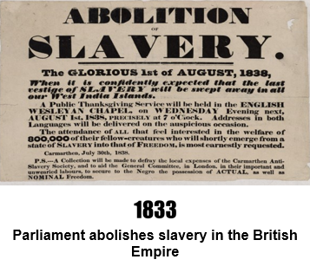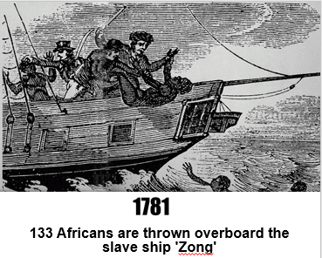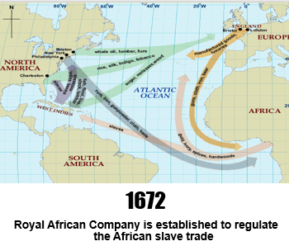
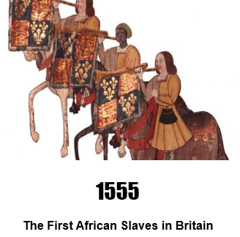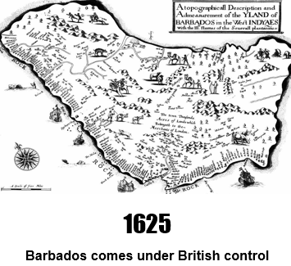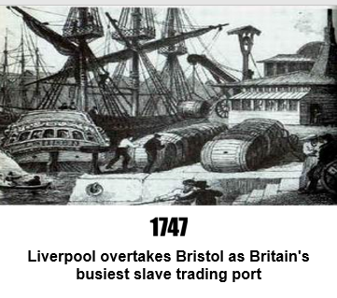

Time line of the Slave Trade

Task 2:
Each statement is a description of an event from your timeline. You need to match the evidence to the event e.g. 1555= statement B
A: In the mid-18th century, Liverpool slave ships made around 49 voyages a year against Bristol's average of 20. Bristol had itself overtaken London as the main slave trading port in 1737. Slave ship owners and the owners of Caribbean plantations, most of whom lived in Britain, became very wealthy and influential in government and society.
B: In 1555 the London trader John Lok brought five slaves from Guinea to England. He was followed by another London trader, William Towerson, who brought African slaves to England in 1556 and 1557.
C: Captain John Powell landed in Barbados in 1625 and claimed the island as a British Caribbean colony. He returned two years later with a group of settlers and Barbados was developed into a sugar plantation economy using at first indentured servants and then slaves captured in West Africa.
D: Charles II granted the Royal African Company a monopoly on the rapidly expanding slave trade. Rival merchants opposed the monopoly and in 1698 Parliament opened the slave trade to all. Britain would become one of the leading transatlantic slave trading nations. Ships took guns and manufactured goods from Britain to West Africa, where goods were exchanged for people. Captives were taken across the Atlantic and sold into slavery on the plantations of the Caribbean and North America. Cargoes of rum, tobacco, cotton and sugar were then carried to England. This was known as the triangle trade.
E: After years of intense anti-slavery lobbying and pro-abolition public meetings around the country (including an abolitionist march on 10 Downing Street) parliament finally voted to end slavery throughout the British empire. Slaves would initially become 'apprentices' for a six-year term, starting in 1834. This was later shortened to four years. MP William Wilberforce, who had represented the abolitionists in the House of Commons, died just days before just before the emancipation measure became law.
F: During a voyage from Africa to Jamaica, the captain of the slave ship 'Zong' ordered 133 slaves to be thrown overboard alive. The ship's owners then filed a fraudulent insurance claim for the value of the dead slaves. In March 1783 the case was heard in London as an insurance dispute rather than a murder trial. The case was widely publicised by outraged abolitionists, particularly Olaudah Equiano and Granville Sharp, and helped to attract new supporters to the abolition cause.

Task 3 answer in full sentences
- How long did the slave trade last for?

- What was traded?

- What countries were involved?

- What major UK cities were involved?

- What does this tell us about the slave trade?

Find out more- choose one of the events in the timeline and find out 5 more facts about the event or a person mentioned.
1.
2.
3.
4.
5.

Part Two-
What was Africa like before the slave trade?
Learning outcome: to explain why Africa was an important trading place.
Key term: Empire- when a country owns or controls other countries.
Before countries like Britain made Africa part of its Empire, many parts of Africa were quite wealthy and had good trade routes. Last year you learnt about Ancient Egypt- a North African country that had a really advanced civilisation and traded with lots of countries. Today you are going to find out more about Africa before the slave trade.
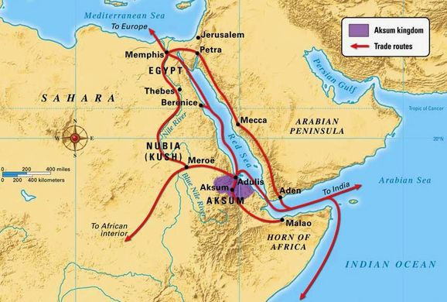
The Aksum Empire
The Kingdom of Aksum was an ancient kingdom of Africa. It is sometimes called the Kingdom of Axum or Ancient Ethiopia. It was located along the southern coast of the Red Sea. It not only conquered and controlled lands in Africa, but the Middle East too. The kingdom covered much of modern day Ethiopia, Sudan, Yemen, and southern Saudi Arabia.
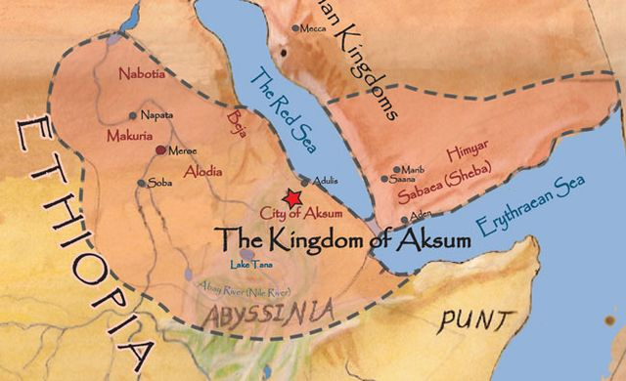
The city of Aksum was formed around 400 BC. It began to rise in power and expand in 100 AD, reaching its peak around 350 AD. It continued to rule the region until 940 AD when it was conquered by a foreign Queen. Aksum reached its peak under the leadership of King Ezana who ruled from 325 AD to 360 AD. During this time, Aksum expanded its territory and became a major trade centre. King Ezana also converted to Christianity, making it the major religion of the kingdom.
Aksum was perfectly located to become a major centre of trade. Merchants would travel from central Africa, Persia, India and Egypt to bring their goods to Aksum to trade. Aksum had access to several different trade routes including major waterways such as the Red Sea and the Nile River. Products traded included salt, gold, ivory, gems, cloth, glass and olive oil. Even people in the Roman Empire would travel to Aksum to buy their goods.

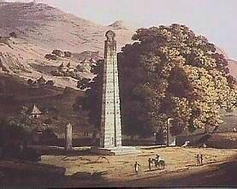
Because of Aksum's location and role in international trading, the culture of Aksum became a blend of many cultures throughout the region. They were influenced by the Egyptians, the Greeks, the Romans and the Arabs. They also developed a written language and minted their own coins. As well as trade they developed terraced farming and irrigation (drainage systems), which allowed them to farm the slopes of mountains, making their hilly land more productive. Unlike their northern neighbours Egypt, Aksum did not build pyramids. Instead, Aksum is famous for building tall towers called stelae. The tallest of these towers was nearly 100 feet high (See image). The towers were elaborately carved with inscriptions, stone doors, and fake windows.

Tasks:
1.Answer the questions about the objects Aksum traded with
- Salt was the most popular product traded in Aksum. Why do you think this is?


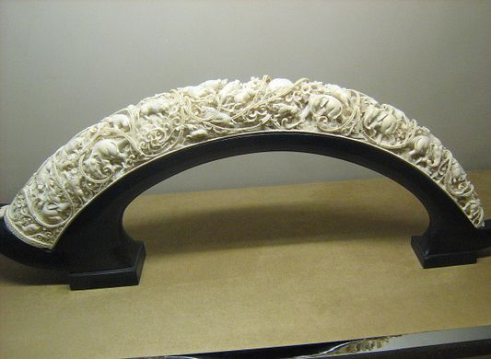
b. Aksum traded ivory (rhino horn and elephant tusks). To prevent extinction, they made ivory sustainable. What does sustainable mean and how would it help trade?

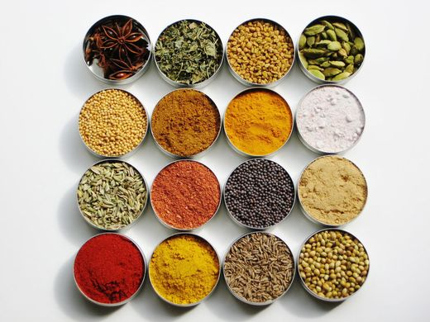
c. Aksum would buy spices and then sell them on. Which countries do you think they would buy the spices from and which countries would they sell it to?

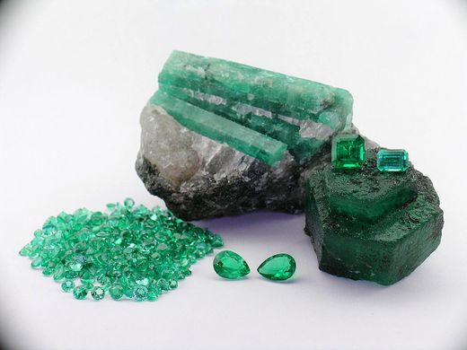
d. Why would emeralds be a popular product to trade?

e. Gold was another very popular product to trade. List all the different things you think gold might be used for
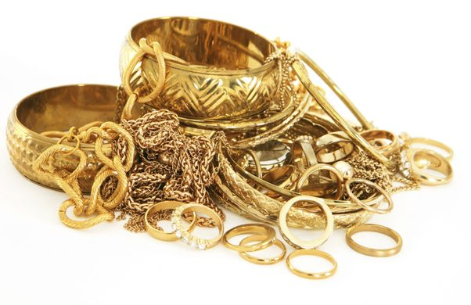
Task 2
You’re the emperor of Rome, wanting to send some men to Aksum to buy their trade goods. You need to persuade the Senate (the Roman government) why it’s worth the long journey to reach this African kingdom
Members of the Senate I am here to tell you why it is really important for us to trade with Aksum in Africa…
Task 3
Write a minimum of three paragraphs to answer the question:
What was Africa like before the slave trade?

