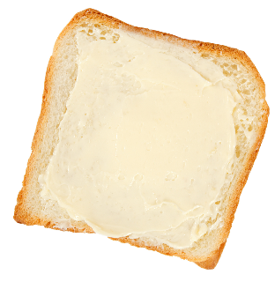
1) 9 × 8 | 2) Calculate 25% of £60. | 3) 4³
4) 6.4 × 5 | 5) 872 – 299 | 6) Simplify the fraction $\frac{16}{48}$.
7) 42 ÷ ___ = 7 | 8) 352 ÷ 16 | 9) 9.2 + 17.82

Bread & Butter

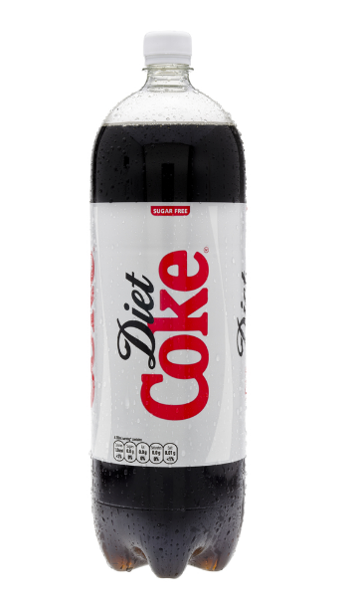

Reasoning

Dewi buys a 2-litre bottle of Diet Coke.
Ian drinks a quarter of the bottle.
Siwan and Eleri drink half of the
remainder of the bottle.
Dafydd then drinks 300 ml of the bottle.
How much of the bottle remains?

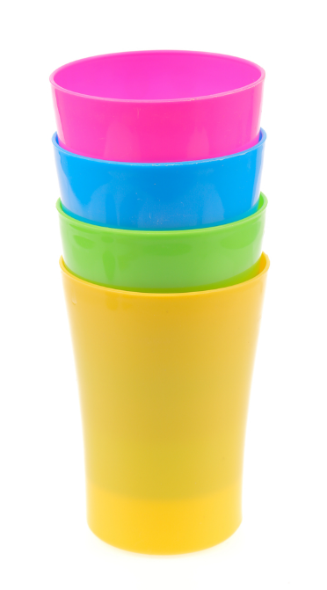

Reasoning

The height of 4 cups (stacked as
shown on the right) is 11.6cm.
A similar stack of 8 cups has height
16.4cm.
What would be the height of a similar
stack of 10 cups?

1) 1% of £75 | 2) Write down 40% as a fraction, in its simplest form. | 3) £32.78 – £9.59
4) 0.4 × 0.3 | 5) What is 6.8 cm in millimetres? | 6) 6 × ___ = 8 × 9
7) 5 × 0 | 8) 221 ÷ 13 | 9) Write down $2\frac{1}{5}$ as a decimal.

Bread & Butter

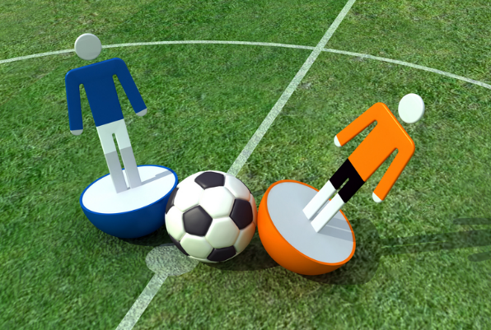

Reasoning

The score at the end of
the football game was
5–2 to the home team.
How many possible
answers are there to
the question “What was
the score at half-time”?

1) 9 × 6 | 2) 6 ÷ 0.25 | 3) Round off 765 to the nearest ten.
4) Take away 84p from £2.17. | 5) $\sqrt{64}-\sqrt[3]{64}$ | 6) Write down 31% as a decimal.
7) The number of sides in a heptagon = | 8) Write down $0.\dot{3}$ as a fraction. | 9) 1 + 2 × 3 – 4

Bread & Butter

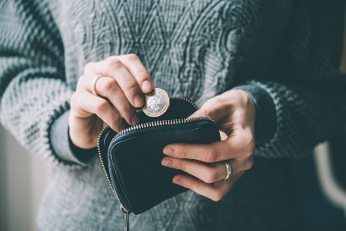

Reasoning

Usually, Seren works a 30 hour
week, earning £8.20 an hour.
She pays one-tenth of her
weekly earnings as tax and
National Insurance.
How much money does Seren have left over to spend each week?

1) 10% of $84 | 2) 823 + 2937 + 83 | 3) 9 × 12.4
4) Round off 630,824 to the nearest thousand. | 5) 5² + 2³ | 6) What is the range of the numbers 90, 40, 20, 60?
7) Which is larger: $\frac{2}{3}$ or 66%? | 8) 9 – 2.14 | 9) Write down half of seven hundred thousand in figures.

Bread & Butter

Reasoning

The dimensions of a cuboid-shaped gold bar are 10cm by 4cm by 3cm.
The bar is melted down and
re-cast to make small cubes with
dimensions 2cm. How many of the
small cubes can be made from the gold bar?


