- Draw in the lines of symmetry in the following shapes:

  - c) e)

  - d) f)

- List the 1st five prime numbers: _______________________________

List all the factors of 10: _______________________________

List the first five multiples of 5: _______________________________

- Fill in the table square

x | 1 | 5 | 9 | 3 | 7 | 10 | 2 | 8 | 6 | 4
3
6
10
4
9
2
8
1
7
Write in figures:

- One hundred and sixty seven thousand, three hundred and one
________________________

- Two million, twelve thousand and four ________________________

Remember when writing numbers in figures:

- 7 1 2 3 7) 4 0 0 0 8) 2 1 8 6
+ 4 1 8 6 —3 1 2 7 — 1 2 1 4

9) 7123 10) 7123
4 4 6 6 8 12 3 3 1 6 8 56

11) 13 + 7.02 + 14.3 = 1716

14) Answer the following:  - 58 x 10= ____________  - 680 x 100= __________ | - 42 x 2000= __________  - 8910 ÷ 10= __________

e) 50000 ÷ 1000= ________ f) 800 ÷ 20= ___________

Find the area and perimeter of the following shapes:

15) 4m area

6m = ______m²

perimeter

=______m

- Write these times as 24 hour times

a) 6:17pm = ______________ b) 4:26am __________________

- List the factors of 30 __________________________________ (8)

- List the first 5 multiples of 12 ____________________________ 21)
- Find the volume of a cube that has the sides of 3cm

Volume = _______cm³

- Share 456 marbles evenly between 3 boys

Each boy will get ______ marbles.

- Betty buys a coat for £97 and trainers for £58. How much does she spend altogether?

£ ____________

- Our school raises£150 for six charities. Each charity gets of the amount raised. How much did each charity get?

£ ____________

- For a school party Mrs Swain buys six boxes of 125 straws each. How many straws did she buy altogether?

___________ straws

- Find:

a) | 50% of 82cm | b) 10% of £30
 | =_______cm | = £_______
c) | 25% of 44cm | d) 40% of £2
 | =_______cm | = £_______

- Plot the following coordinates and join them up to make a picture:

(5,9) (1,6) (2,6) (2,1) (4,1) (4,3) (6,3) (6,1) (8,1) (8,6) (9,6) (5,9)

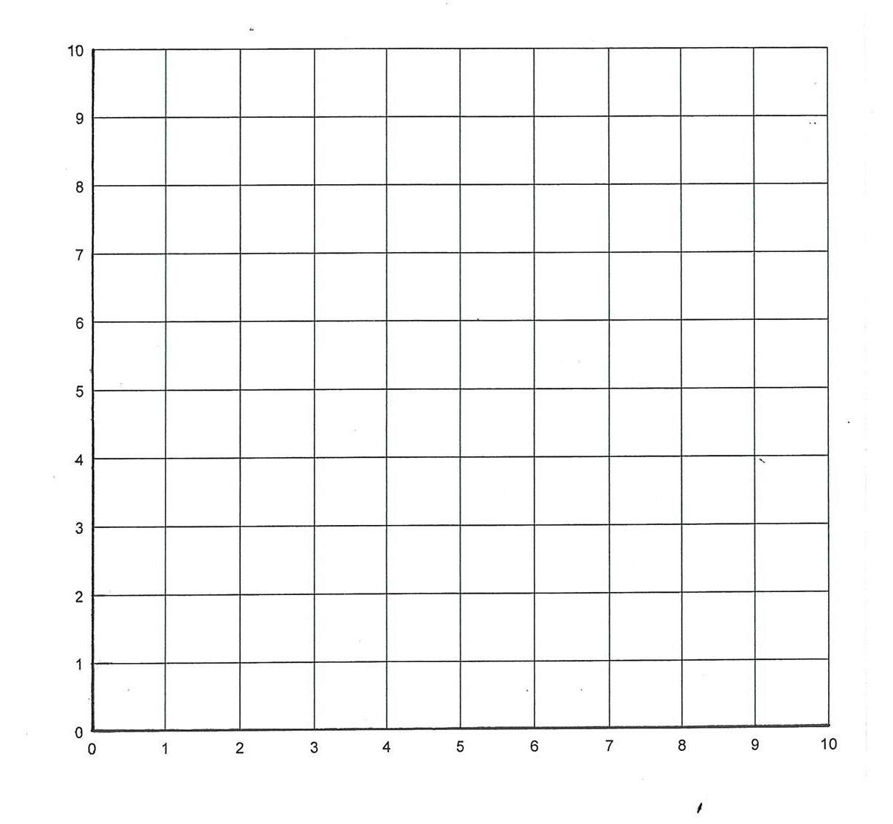
- Fill in the following table using the number machine:

x 3

+

4

IN OUT

IN | OUT
4 | 16
10
7
 | 22
 | 10

Write in figures:

31) Twenty two thousand, four hundred and seventy six.
________________________

32) 7 3 3 3 + 4 2 1 6  35) 7123  6 6 5 8 2 12 | 33) 4 1 6 8 — 1 2 1 4  36)  7123  4 4 2 6 4 56 | 34) 6 0 0 0 — 4 7 2 6  37) 7 8 1 5 x 6
39) 15 + 1.68 + 12.1 =

40) Answer the following:  - 56 x 10=____________  - 720 x 100=__________  - 24 x 2000=__________ | - 4510 ÷ 10=__________  - 80000 ÷ 1000=________  - 600 ÷ 30=___________

- Write these times as 24 hour times

a) 2:27 am = ______________ b) 2:27 pm _________________

