Negative numbers

BRONZE
Finish these number lines:

-6 0 3

-10 -8 0 2 6

-30 -20 0 10 15

-60 0

SILVER
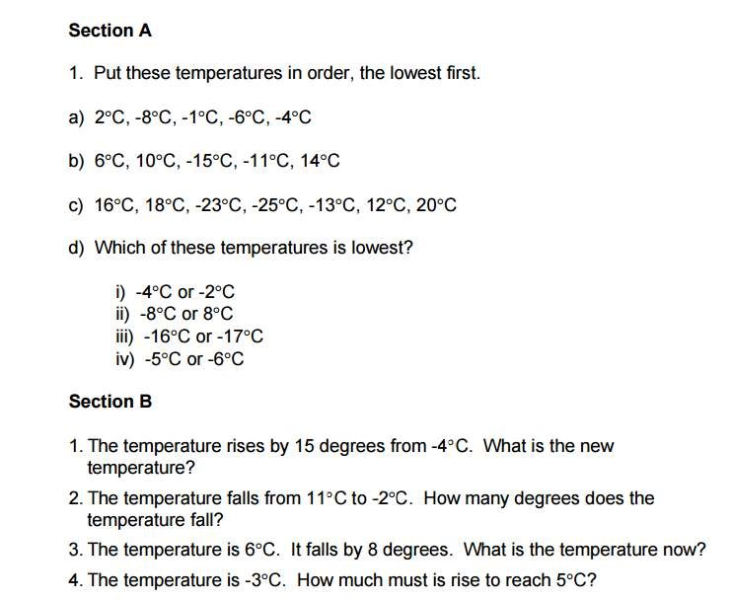

GOLD
Complete the table
Planet | Hottest recorded temperature | Coldest recorded temperature | Difference
Kark | 10°C | -5°C | 15°C
Hikl | 126°C | 37°C
Topa | 54°C | 12°C
Uni-7 | -13°C | -179°C
Jolarg | 54°C | -68°C
Vortan | 104°C | -97°C
Intop | -95°C | -214°C
Yurg | -27°C | -163°C

Number patterns

BRONZE
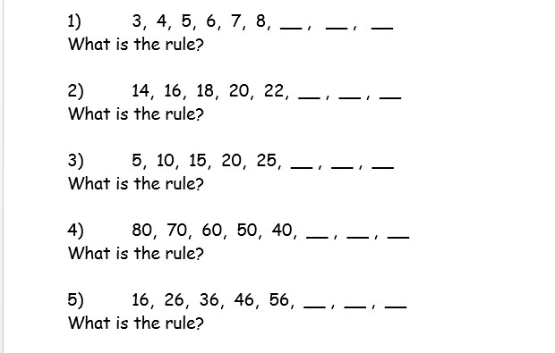

SILVER
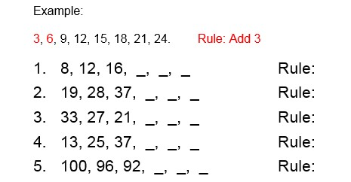

GOLD
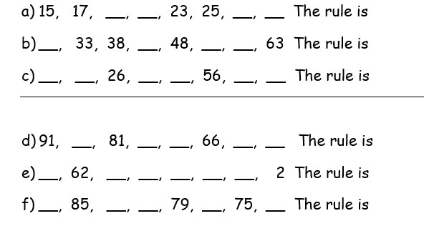

Money problems

BRONZE
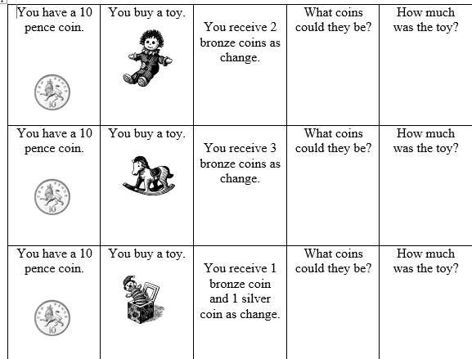

SILVER
1, Oranges cost 49p a kg, apples 39p a kg. I buy 1kg of each and pay with a £1. How much change do I get?

2, I buy two packets of crisps for 27p. How much change do I get from £1.

3, I buy 3 apples for 21p each. How much change would I get from £1?

4, A pen costs 70p a pad 55p. How much change would I get from £2?

5, I buy a rubber for 45p and a ruler for 44p. How much change would I get from a pound?

Addition and Subtraction

BRONZE
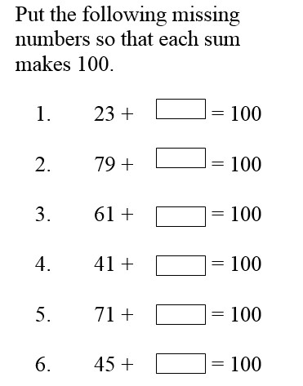

SILVER
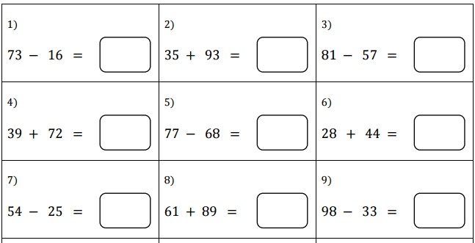

GOLD


