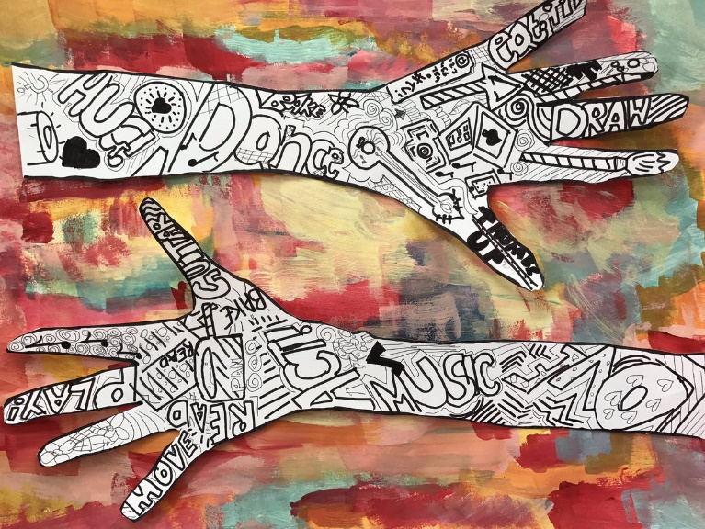
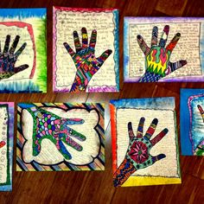
KS3
List all the things that make you YOU. This can be things you enjoy doing, ethnicity, culture, heritage, religion, things that are important to you, things you are good at and people that are important to you.

What makes you YOU?
gender , social class, age, sexual orientation, race and ethnicity, religion, age and disability
IDENTITY
art@stmatthias

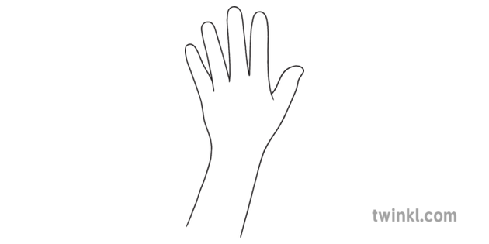
TASK: Inspired by the hand art on the previous page, add patterns, words and images to the following outlines of hands using your medium (art material ) of choice. This could be biros, pens, pencils or whatever you have to hand (excuse the pun!).
CHALLENGE TASK
Draw your own hands from observation and add a design to them



