Addition
Fill in the empty boxes by adding together the two boxes below.

In a magic square every row column and each diagonal must add up to the same ‘magic number’.

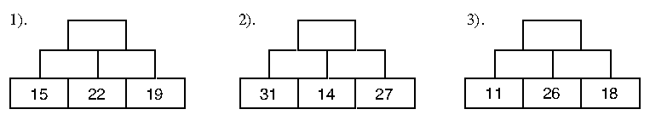

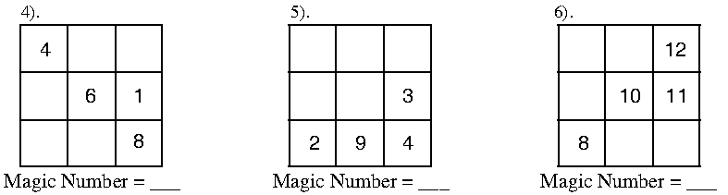

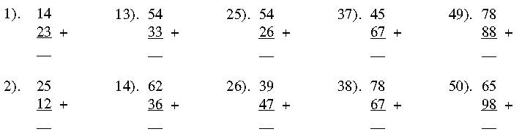
Column Addition

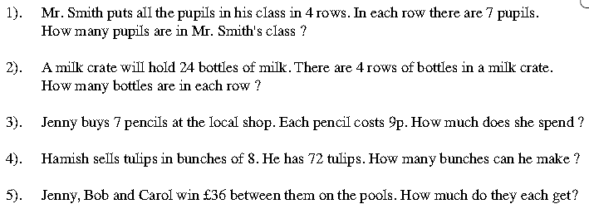
Worded questions – Multiply and Divide

If you add two numbers together then the answer is called their sum.
If you multiply two numbers together then the answer is called their product.
e.g. The sum of 4 and 7 is 11 because 4 + 7 = 11
The product of 4 and 7 is 28 because 4 x 7 = 28
See if you can work out the answers to the problems below

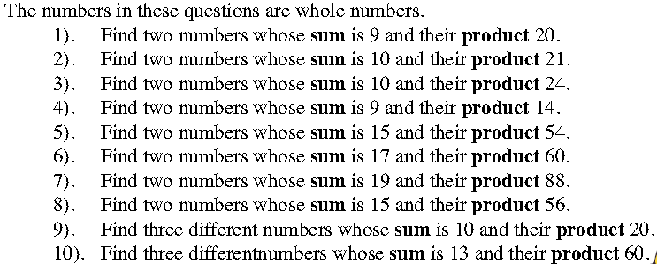

Multiplying and Dividing by powers of 10
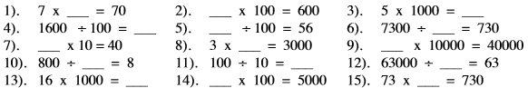

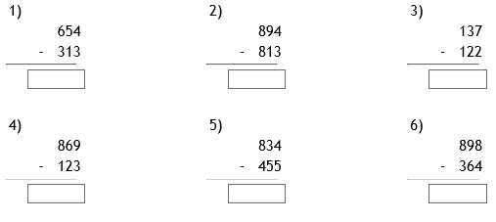
Subtraction

Time – Write down how many hours and minutes have passed between the first and second times in each question. e.g. 11.25 to 13.10 = 1 hour 45 mins


