


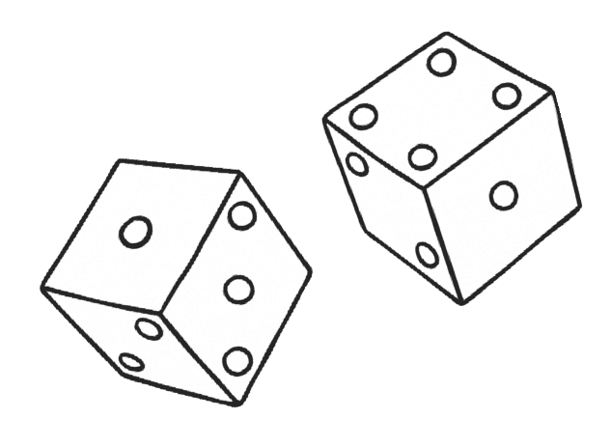
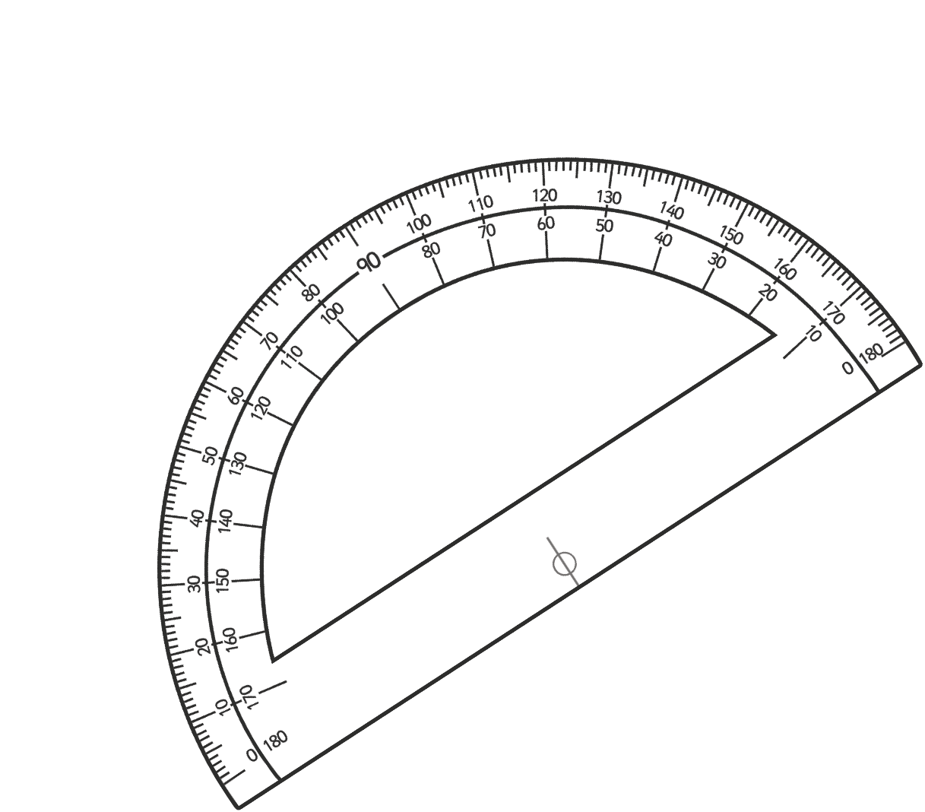
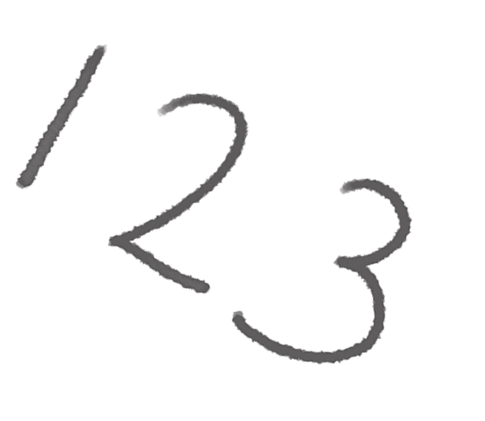
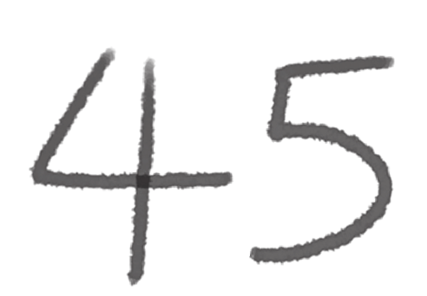

Number Partitioning
1.
+
+
+
+
+
1
2
=
2.
+
+
+
+
8
5
=
3.
+
+
+
+
+
2
3
=
4.
+
+
+
+
4
3
=
5.
500 000
+
+
+
+
10
=
6.
400 000
+
+
+
+
+
4
=
7.
800 000
+
+
+
+
8
=
8.
100 000
+
+
+
+
+
7
=
9.
+
+
+
+
+
7
9
=
700 000
Page 3 of 28

20

8000

2

8

4

2

90

400

1000

10 000

20

300

6000

80

400

3000

70 000

600

3000

60 000

0

3

6

2

6

4

7

8

2

7

0

4

5

6

8

9




Ordering Numbers to 10 000
Fill in the spaces below with the numbers in order from smallest to largest.
2212
2012
1201
1022
2120
7676
6776
6677
7767
7776
4849
4948
4489
4994
449
1161
6161
1616
6611
6616
7220
2770
770
720
2707
visit twinkl.com
Page 4 of 28

Ordering Numbers to 100 000
Fill in the spaces below with the numbers in order from smallest to largest.
35 435
34 534
35 533
34 453
34 543
89 998
89 989
88 988
88 899
89 899
17 717
7771
7177
77 717
71 717
25 645
26 255
25 562
24 654
25 622
4091
491
4901
914
9410
visit twinkl.com
Page 5 of 28

Ordering Numbers to 1 000 000
Fill in the spaces below with the numbers in order from smallest to largest.
245 452
254 245
45 254
452 524
54 542
90 900
909 009
999 909
990 009
99 900
368 863
683 836
683 863
836 368
386 386
725 500
527 700
77 500
55 200
725 700
110 001
111 010
11 110
111 101
110 100
visit twinkl.com
Page 6 of 28

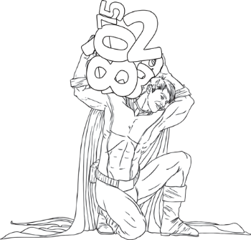
Writing Numbers to 1 000 000 in Words
Write the following words in numbers:
visit twinkl.com
Page 7 of 28

23 443

Twenty-three thousand, four hundred and forty-three

51 623

78 785

33 091

60 696

402 341

589 130

645 099

840 781

709 118

112 098

245 590

390 519

101 010

Writing Numbers to 1 000 000 in Numbers
Write the following words in numbers:
visit twinkl.com
Page 8 f 28

Two hundred and forty-five thousand, eight hundred and forty-six

245 846

Six hundred thousand, seven hundred and thirty-two

Nine hundred and thirteen thousand, five hundred and forty-one

Seven hundred and fifteen thousand, two hundred and twenty-eight

Four hundred and six thousand, seven hundred and ninety-four

Nine hundred and thirty-six thousand, two hundred and fifty-five

One hundred and seventeen thousand and four

Five hundred and thirty-five thousand, seven hundred and six

Two hundred thousand and twenty-two

Four hundred and eighty-eight thousand and sixty

Eight hundred and forty-eight thousand, nine hundred and three

Nine hundred and ninety-one thousand, one hundred and nineteen

One hundred and ninety-nine thousand, nine hundred and nineteen

Five hundred and fifteen thousand, one hundred and fifty-one

