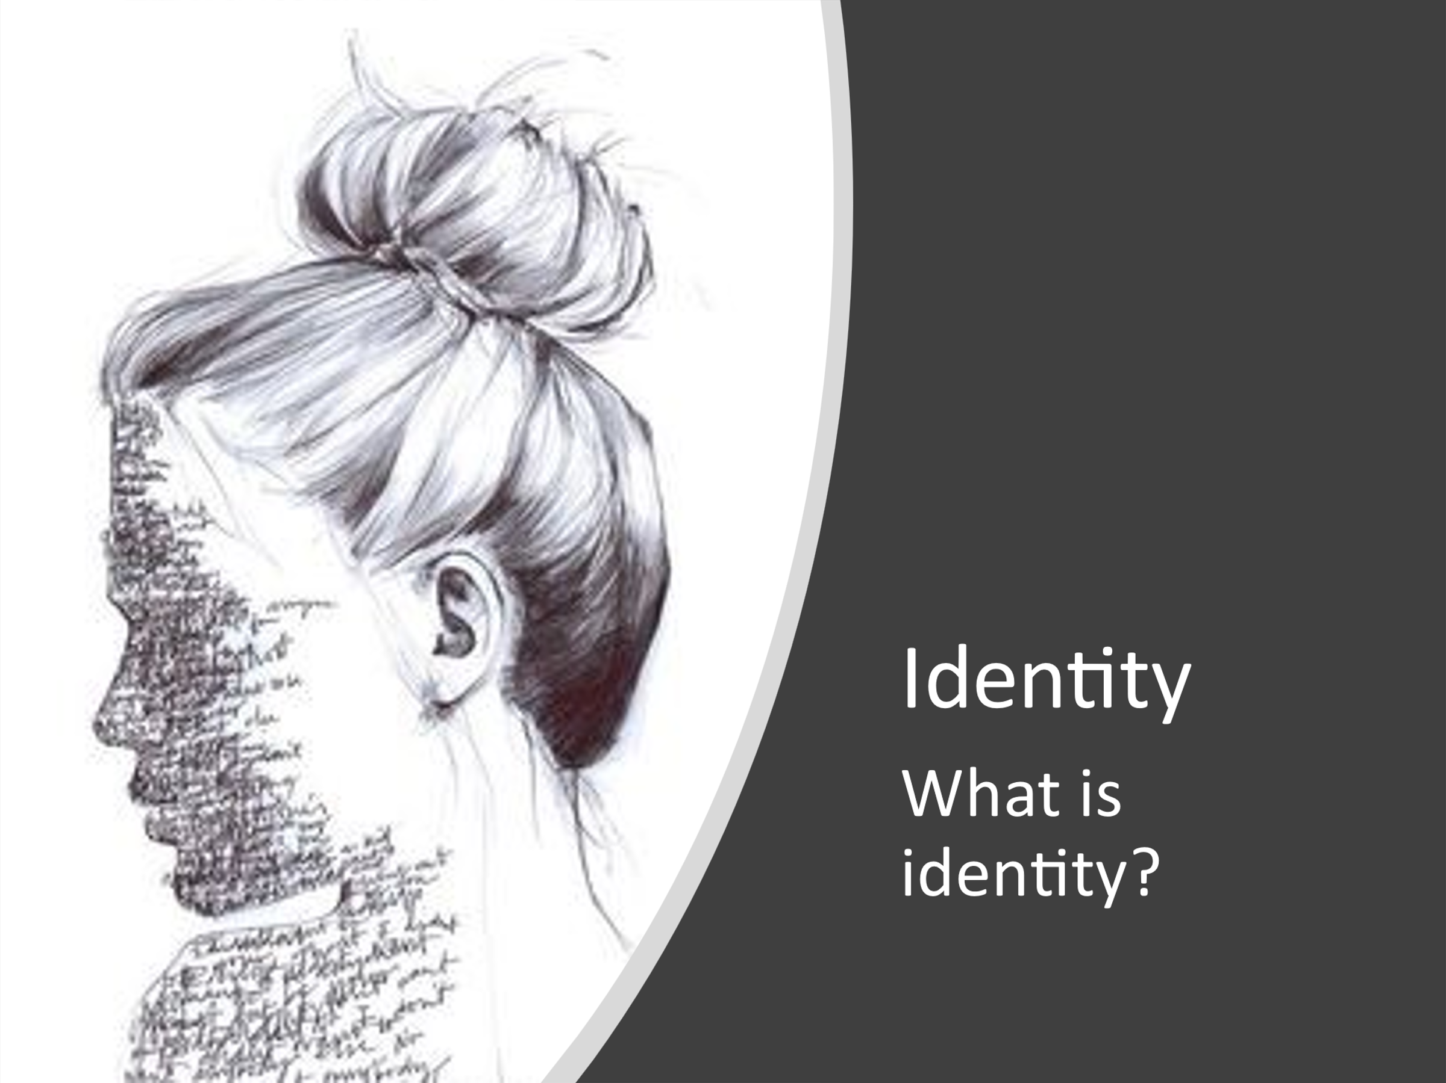
art@stmatthias
- The definition of identity is who you are, the way you think about yourself, the way you are viewed by the world and the characteristics that define you.
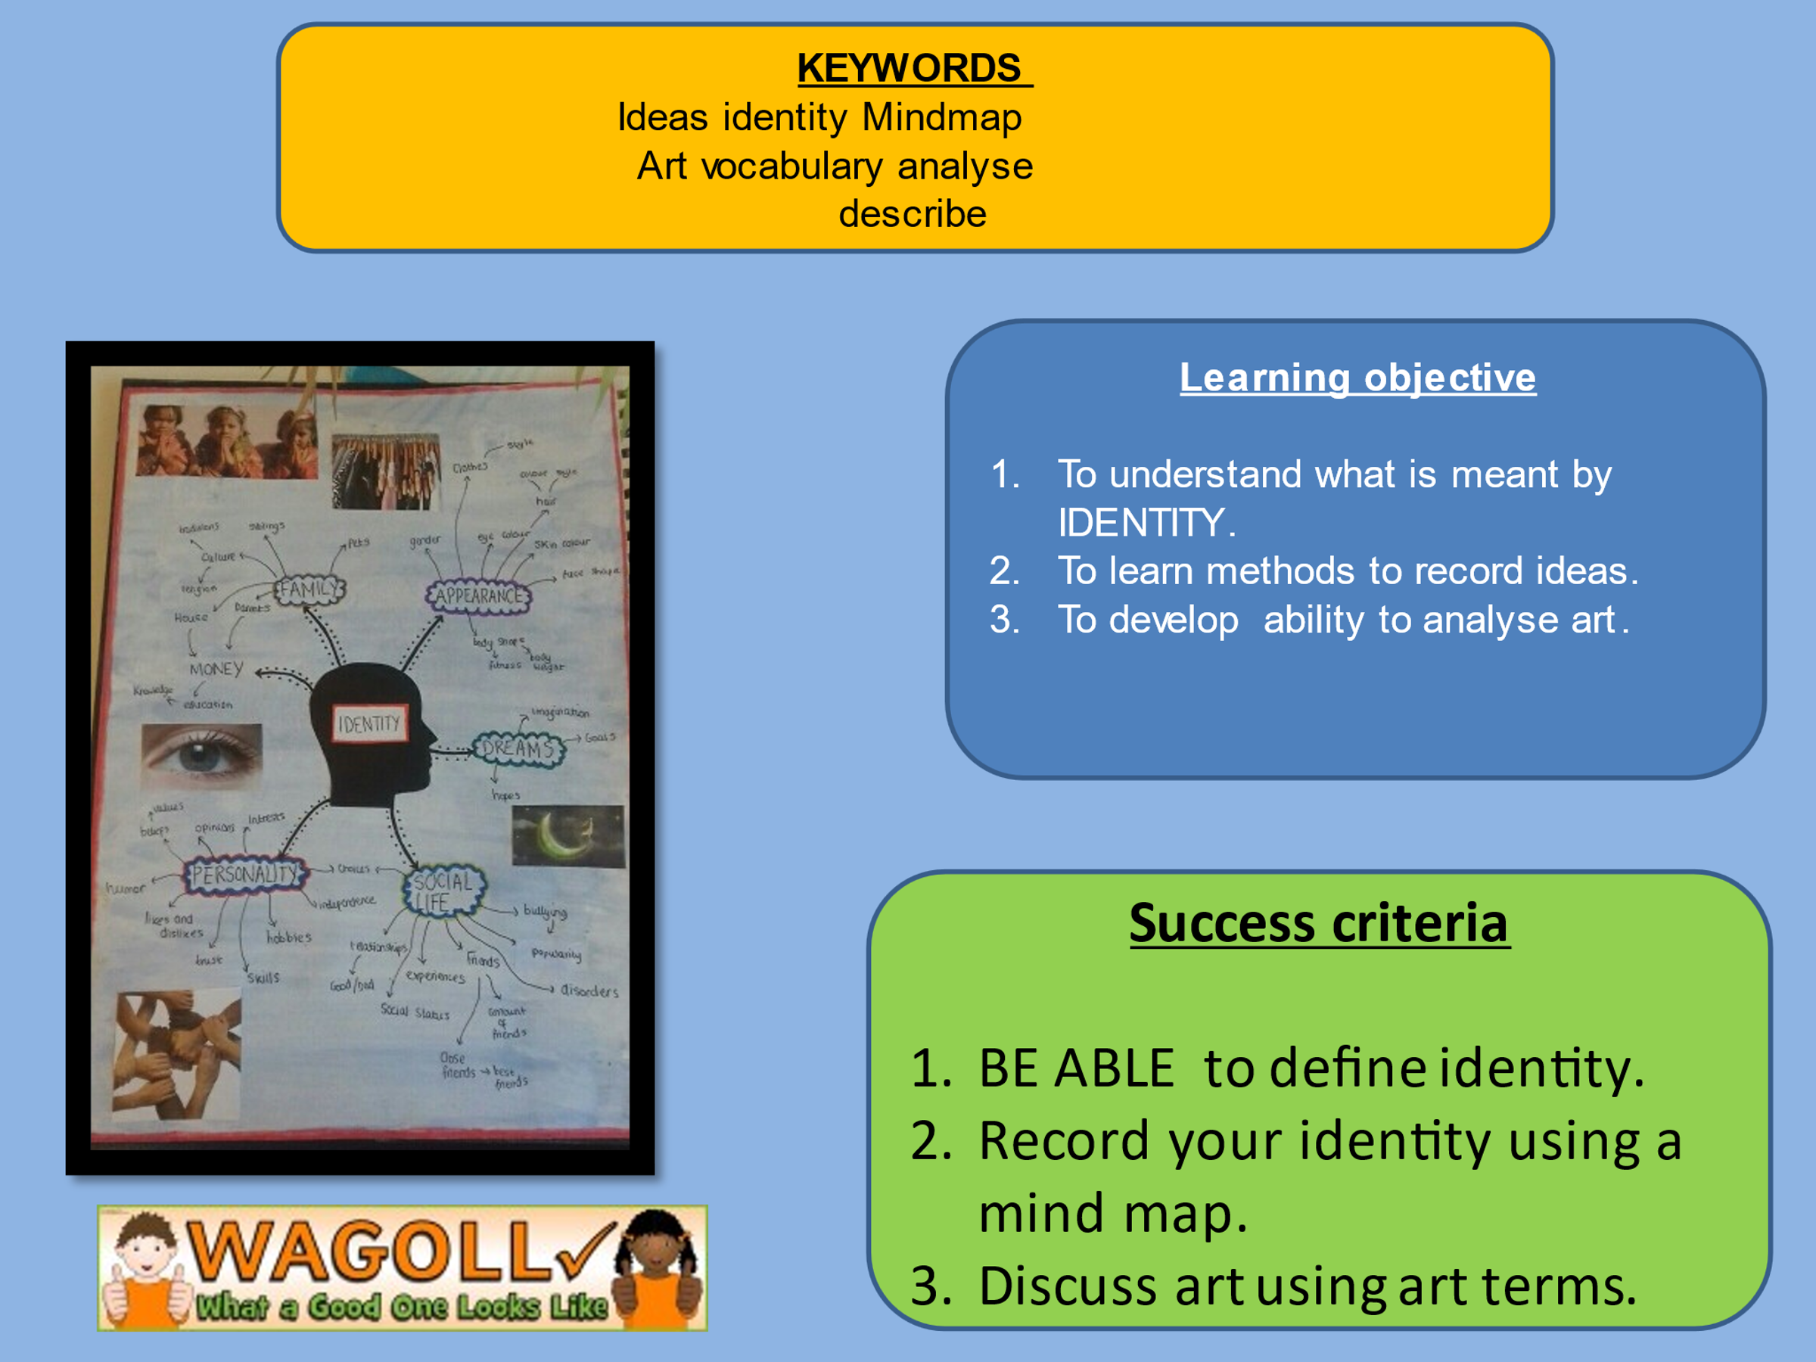
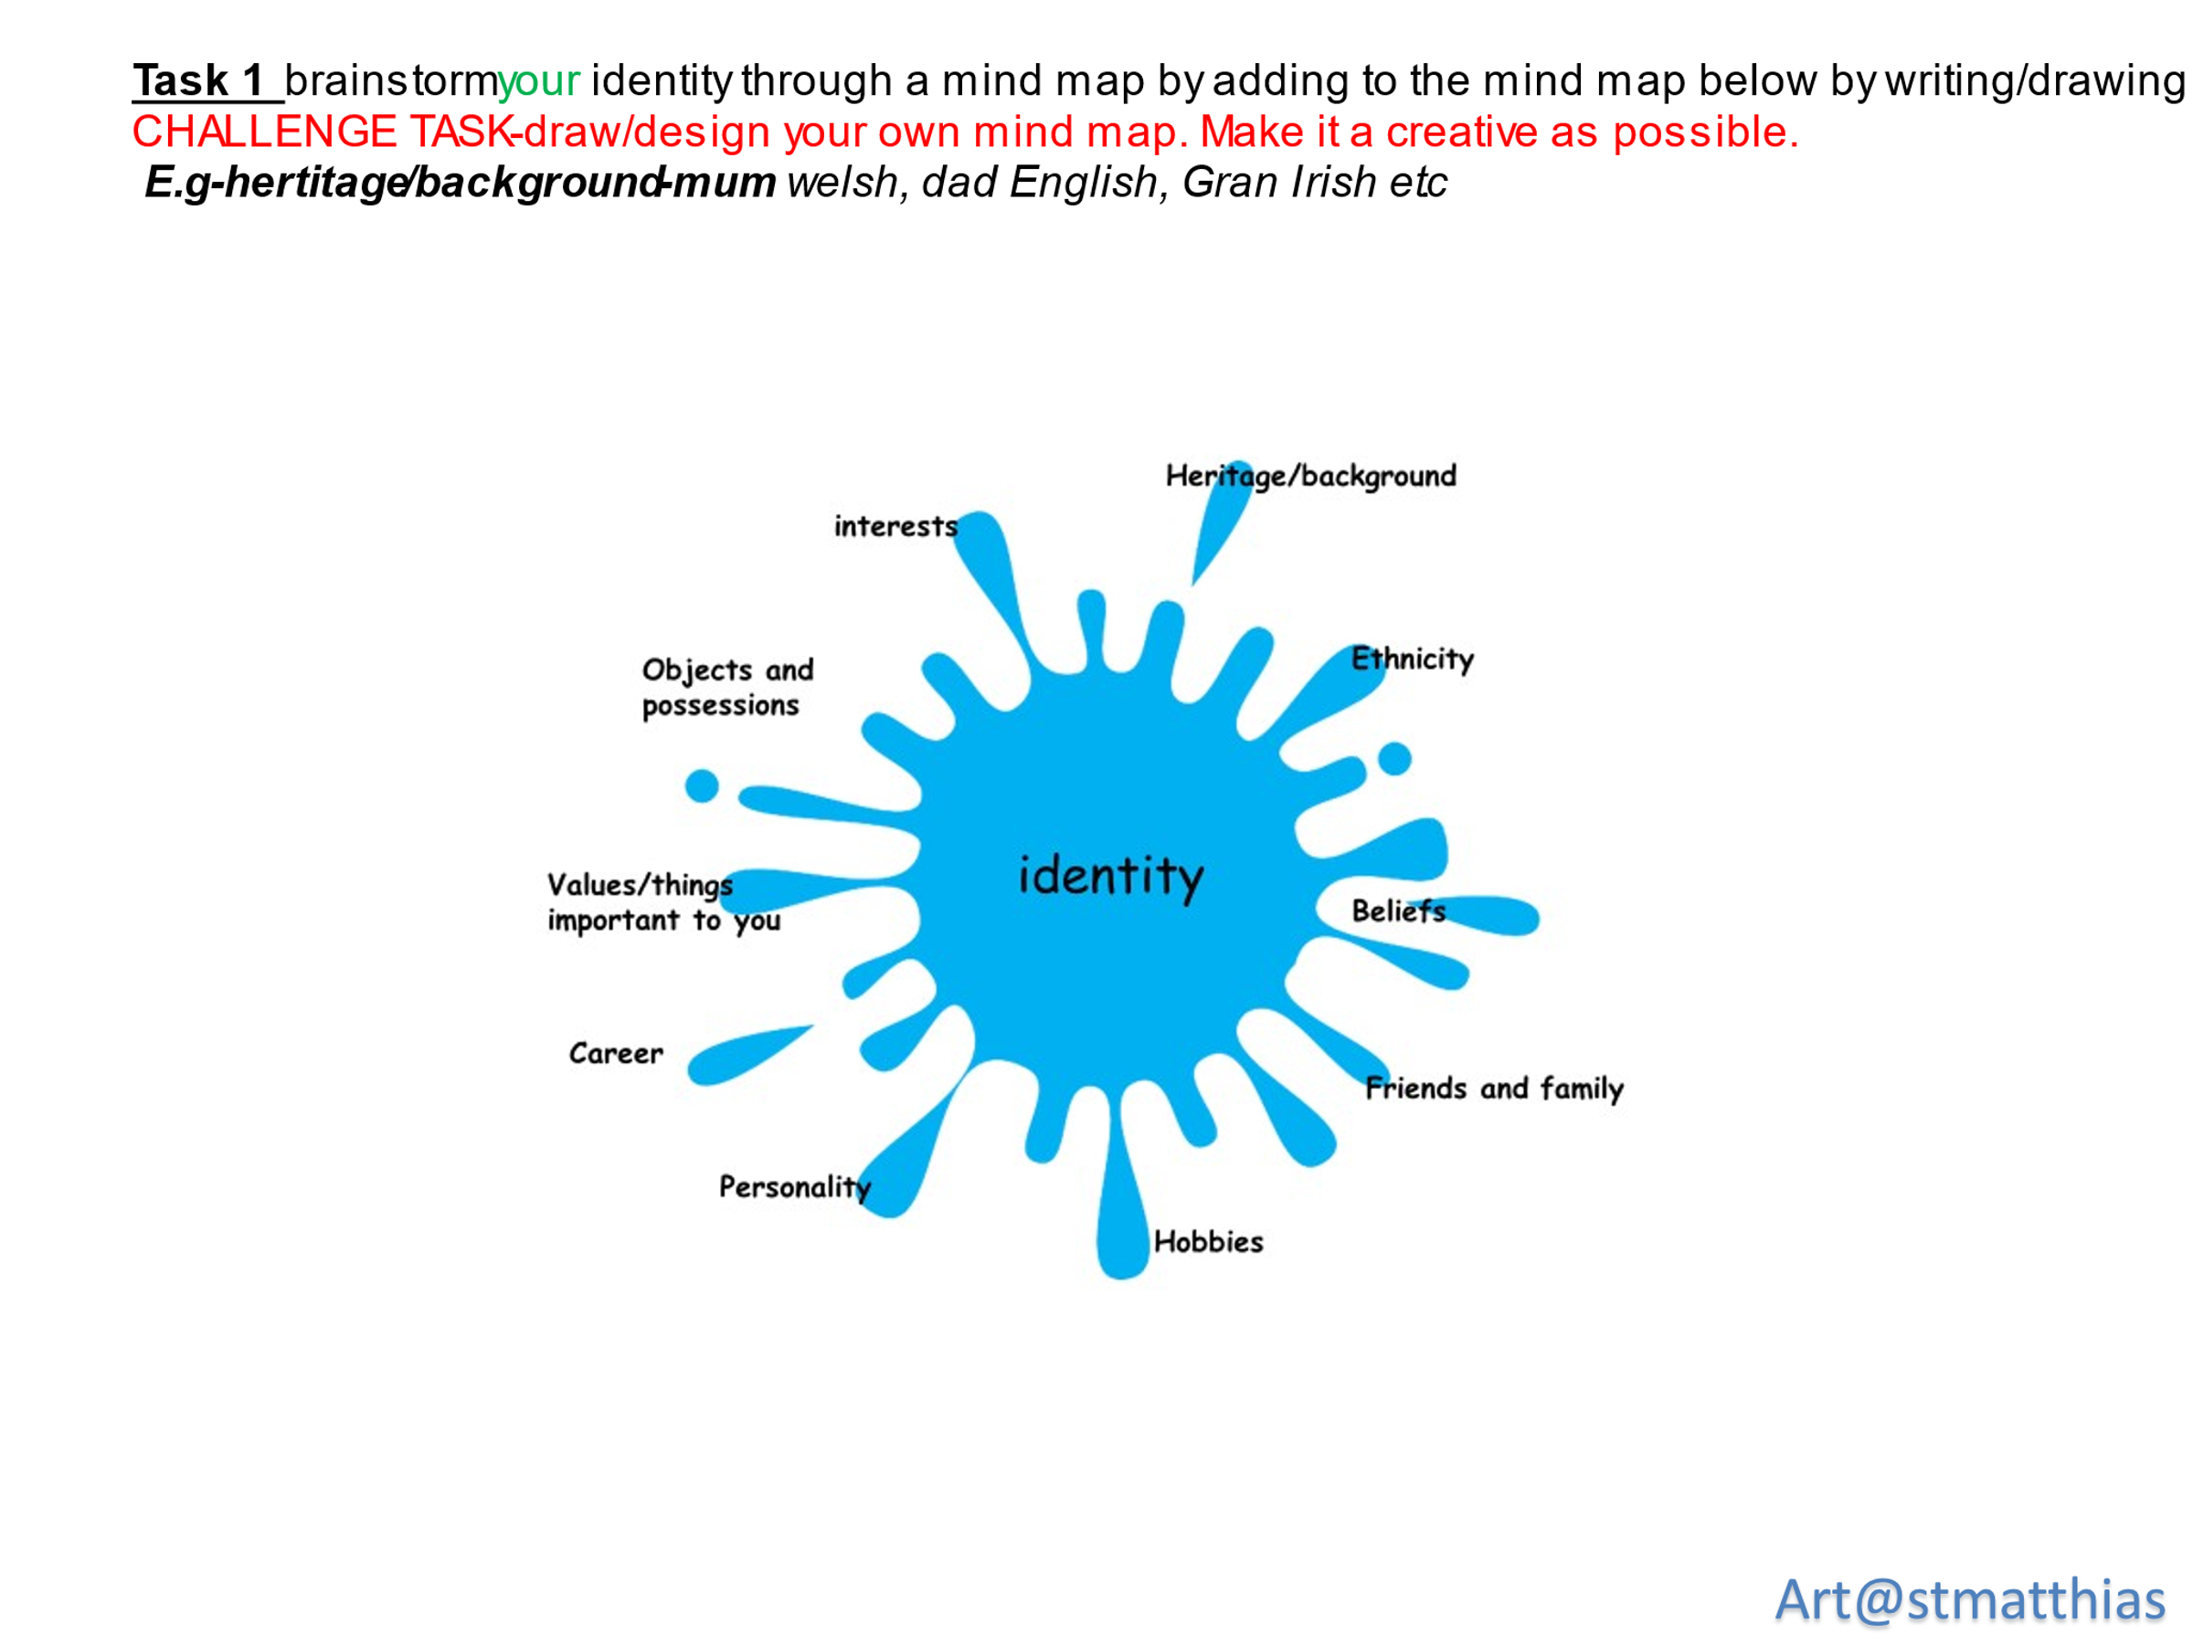

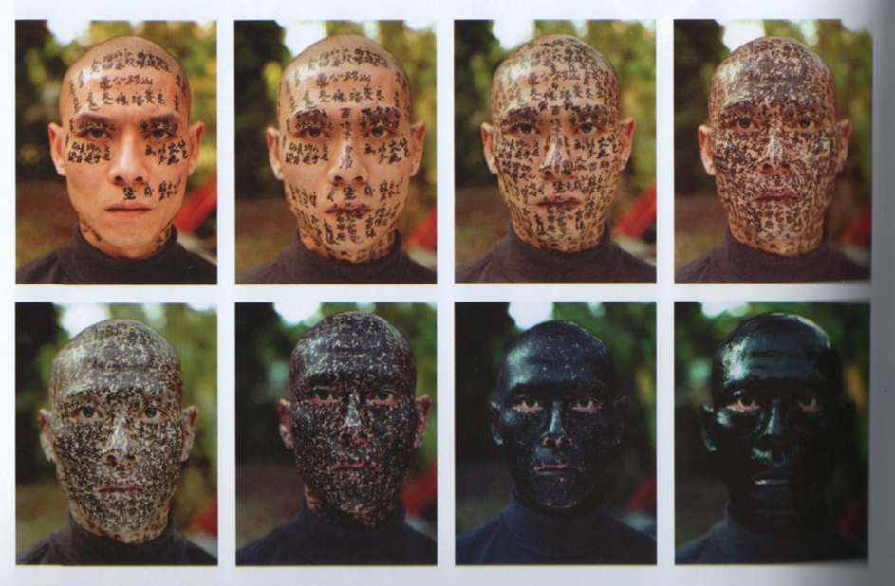
Zhang Huen is an artist inspired by his cultural identity.
For ‘Family Tree’ he has his face covered in writing from a traditional chinese tale. ‘I cannot tell who I am, my identity has disappeared’

IDENTITY Research
Name of artist_Zhang Huen
What things do you see in the work of art?

In your opinion is it art?
No
Yes

What art form is it? _____________________
Painting drawing sculpture installation video ceramics mixed media photography

What do you like/dislike about the art?

Why do you think the artist created it?

Using the internet, try to find out 4 facts about the artist.
1

2

3

4

Task 3. Inspired by Zhang Huen, draw a basic SELF PORTRAIT (drawing of you self) and use the words from your mind map to write over it/behind it.
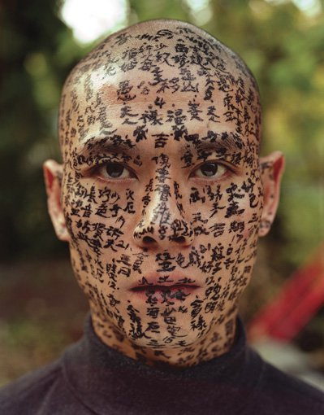

You can use the following outline.



