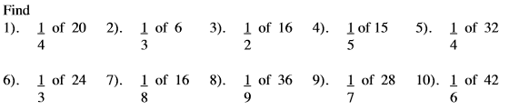
Fractions of Amounts

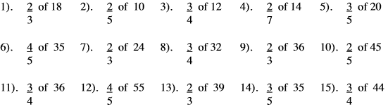

Percentages – Percentages of amounts
- 10% of 40 = 2) 10% of 70 = 3) 10% of 34 =
4) 10% of 230 = 5) 20% of 80 = 6) 20% of 120 =
7) 20% of 45 = 8) 50% of 40 = 9) 50% of 88 =
10) 50% of 15 = 11) 30% of 70 = 12) 5% of 40 =
13) 5% of 28 = 14) 90% of 50 = 15) 35% of 40 =

1 . Write these numbers in order of size.
Start with the smallest number.
(a) –6, 2, –1, 0, –3
.....................................
(1)
(b) 0.6, 0.64, 0.06, 0.604, 0.064
.....................................................................................
(1)
(Total 2 marks)
2. Write the number 3927 correct to 1 significant figure.
…………………….
(Total 1 mark)
3. There are 800 people on a train at Manchester.
of these 800 people are children.
4. Work out of 800
…………………….
of these 800 people are women.
(ii) Work out of 800
…………………….
(Total 3 marks)
(a) Work out of 30
............................................
(2)
(b) Write as a decimal.
5. (a) Write 0.85 as a percentage.
............................ %

(1)

(b) Write as a percentage.
............................ %
(1)
(c) Write 60% as a decimal.
................................
(1)
(Total 3 marks)
6. Work out 70% of £340
£ ..........................................
(Total 2 marks)
7. (a) Write 0.38 as a percentage.
………………… %
(1)
(b) Write as a percentage.
………………… %
(1)
(Total 2 marks)
8. Richard paid 56p for 7 pencils.
The cost of each pencil was the same.
Work out the cost of 4 of these pencils.
......................... p
(Total 2 marks)
9.
What fraction of the large triangle is shaded?
Give your fraction in its simplest form.
………………………

.
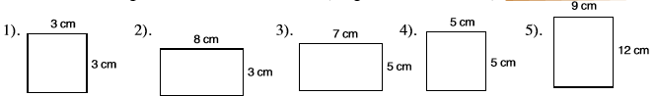
Area and Perimeter
Area ______
Perimeter ______
Area ______
Perimeter ______
Area ______
Perimeter ______
Area ______
Perimeter ______
Area 3 x 3= 9cm²
Perimeter 3+3+3+3 = 12cm_

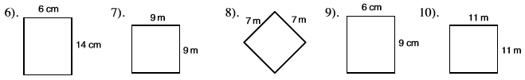
Area ______
Perimeter ______
Area ______
Perimeter ______
Area ______
Perimeter ______
Area ______
Perimeter ______
Area ______
Perimeter ______

Area of a Triangle
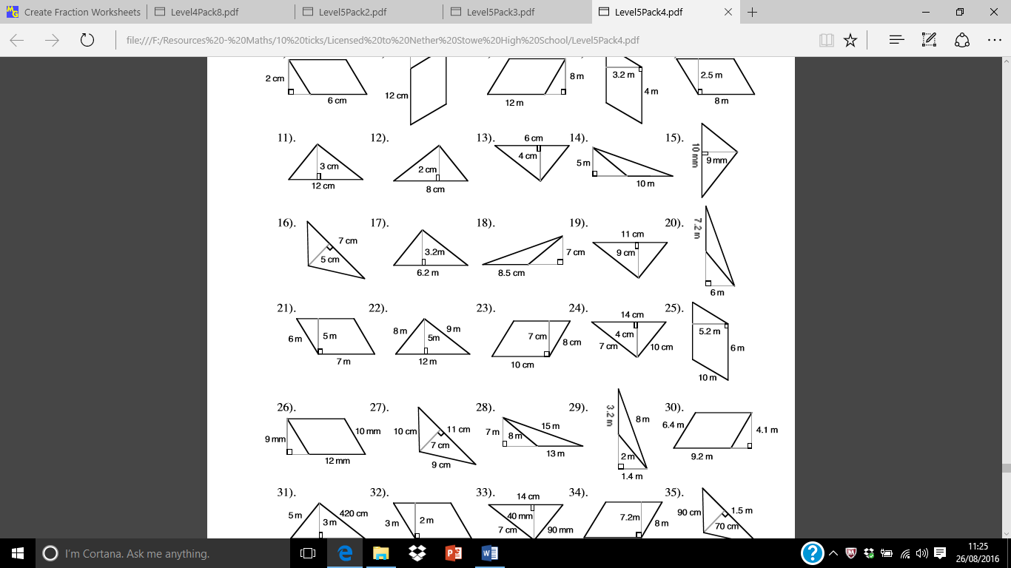
Area 12 x 3 =36 / 2 = 18 Area ________ Area ________ Area ________

