Structure:
N. the arrangement of and relations between the parts or elements of something complex.
V. construct or arrange according to a plan; give a pattern or organization to.
This is the first question that you have to look at the whole source.
You will still need to break it down and look at specific paragraphs and sentences.
Question 3

This question will always focus on structure. You will need to think about how the
writer uses structure to achieve effects
and influence the reader.

The focus changes depending on the extract
You need to think about the whole of the source.
This text is from the ending of the novel.
How has the writer structured the text to hold the reader’s attention?
You could write about:
- What the writer focuses your attention on at the beginning
- How and why the writer changes this focus as the extract develops
- Any other structural features that interest you. [8 marks]

You need to think about the structural techniques that thehe writer has used to produce a desired effect.
Go to the next page to see how your answer will be marked.
This is where people get a bit confused, as they do not have as much experience of analysing structure.
Use the glossary on the next couple of pages to help you.
Remember to use technical terms.

Level 4  7-8 marks | Perceptive, detailed analysis | Analyses the effects of a range of structural features in detail with sophisticated and accurate use of technical terminology. Use of a perceptive range of examples from across the source.
Level 3  5-6 marks | Clear, relevant explanation | Clear explanation of the effects of the structural features with technical terminology used throughout. Suitable examples are used and explained.
Level 2  3-4 marks | Some understanding and comment | Some explanation of some structural features – not necessarily from the whole of the source. Some technical terminology used but may not be accurate. Some examples used to support points.
Level 1  1-2 marks | Simple, limited comment | Basic comments on a few features – no real focus on whole of source. Simple or no mention of subject terminology, which may also be inaccurate. Few, irrelevant examples are used.

What is structure?
How authors internally organise a text.

“As authors write a text to communicate an idea, they will use a structure that goes along with the idea.”
Meyer 1985

When looking at structure, you need to think about how the text is written and what it looks like rather than focusing on the language that is used.

How do you analyse structure?
The question will you give you some bullet points which you could use to guide your answer:
- what the writer focuses your attention on at the beginning
- how and why the writer changes this focus as the extract develops
- any other structural features that interest you.

Structural features and techniques
Feature | Definition
Atmosphere | The mood or tone of the extract created deliberately by the writer.
Climax | The most intense point in the extract.
Closing paragraph | The final paragraph of the extract. Think about what the paragraph is about, whether it links to any previous paragraphs and whether it had been foreshadowed earlier in the extract.
Exposition | The start where details are usually shared.
Flashback | Past events are re-visited.
Foreshadowing | A hint of what might happen in the future/events that are to come.
Motif | A recurring idea in the extract – might be in the shape of a theme, object or character.
Opening paragraph | The start of the extract. Think about who is introduced, what we are told/not told, the perspective and focus.
Paragraph | One section of the extract, which can vary in length. You must start a new paragraph for a new time, place, topic or person speaking. You might also want to change a paragraph in order to:  - Sustain: more of the same  - Develop: add elaboration and variety to first idea.  - Contrast: adopt a completely different perspective or position to move the story forward.
Perspective | Whose point of view is the extract from? What is there particular attitude towards what is happening?
Setting | Time and place where the events of the extract take place.
Shift | A move or change in focus.
Tension | A degree of emotional strain. Think about when the tension starts in the extract and how it is developed.
Narrative styles
Linear | Events are told in chronological order.
Non-linear | Events do not occur in chronological order.
Dual | Told from multiple perspective.
Cyclical | Ends the same way that it begins – same perspective or idea.
Types of narrator
Omniscient narrator (3rd person) | External narrator who has knowledge of the characters and their feelings/emotions. Not named or present within the narrative.
1st person | Told from a specific character’s perspective (I)
2nd person | Directed to the reader (You)
Unreliable narrator | The perspective that this narrator offers makes the reader question its credibility and reasoning.
AQA have provided the following jigsaw framework to help you think about the structure of an extract – try to think about the 5 ws!
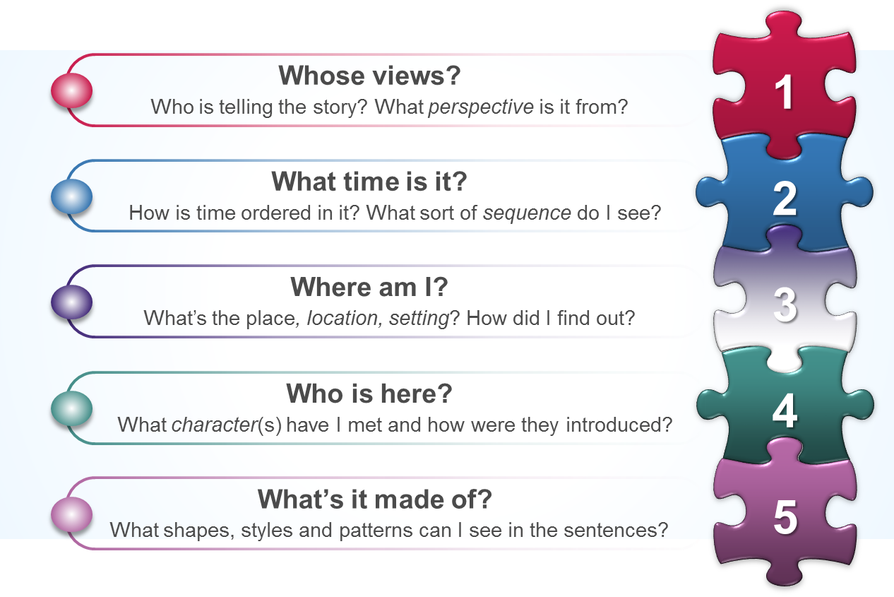

- The (narrative) perspective of the text (what?)
- The organisation and use of time (when?)
- The location and setting (where?)
- Characters and how they are introduced (who?)
- The different patterns within the text, and elements of syntax or cohesion that help to create (reinforce) meaning (how?)

Because this question focuses on the whole of the extract, you will need to talk about its overall structure rather than just focusing on a specific part. Also, try to think about:
- Paragraph level features – connections between them, length, shifts in perspective and repetition.
- Sentence level – you are not analysing the language of the sentence but can comment on how varying the sentence lengths add to the overall structure of the text.

Read the context box at the start of the extract as this might tell you where the extract is positioned in the book – how does this influence and effect the overall structure of it?
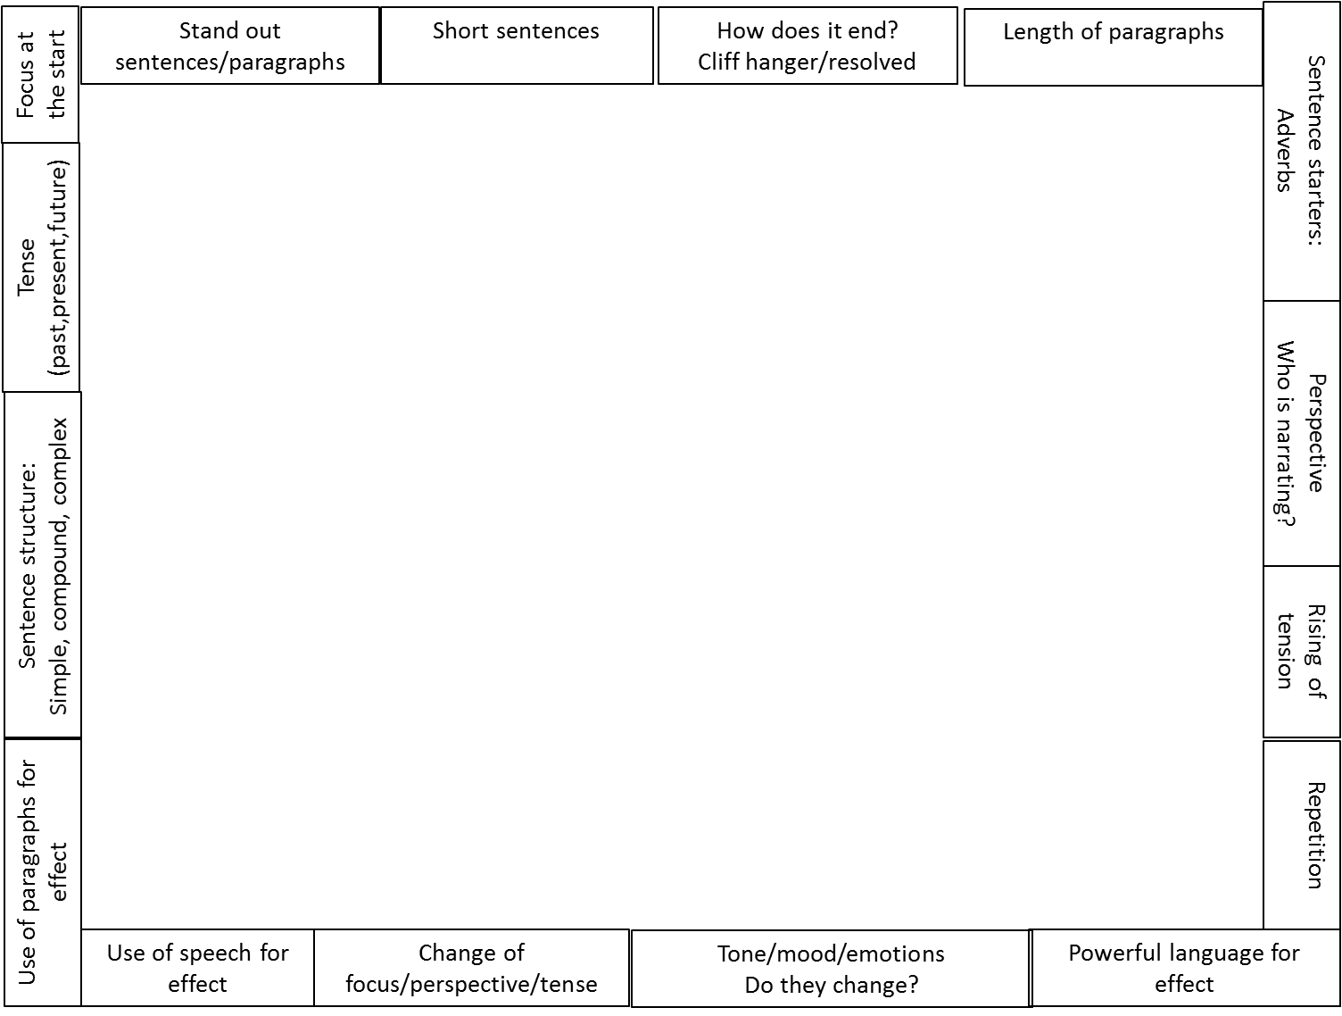
These are some of the things that you can focus on in your exam.

When attempting the practice questions, why not place the extract in the centre and identify the different features.
You need to think about the whole of the source.
This text is from the start of the novel.
How has the writer structured the text to hold the reader’s attention?
You could write about:
- What the writer focuses your attention on at the beginning
- How and why the writer changes this focus as the extract develops
- Any other structural features that interest you.

Step by step guide:

- Read the question and highlight the key words:
How has the writer structured the text to hold the reader’s attention?
- Read back through the extract, annotating the structural features. Focus initially on:
  - Opening paragraph focus
  - Closing paragraph focus
  - Similarities between the opening and closing
  - Paragraph length – do any stand out because they are unusually short/long?
  - Narrative perspective – is it the same/does it change?
  - Repetition of theme/objects/ideas/motif
  - Position of the extract in relation to the whole novel

Let’s look at an example annotation of this extract.
She backed up a few steps, then ran at the water. At first her strides were long and graceful, but then a small wave crashed into her knees. She faltered, regained her footing, and flung herself over the next waist-high wave. The water was only up to her hips, so she stood, pushed the hair out of her eyes, and continued walking until the water covered her shoulders. There she began to swim - with the jerky, head-above-water stroke of the untutored.
Shark
Woman
This paragraph instantly introduces us to a character and what they are doing.
Some questions are left unanswered – why did she back up initially? Why is she in the water? What water is she in?
We also question why she is swimming if she is ‘untutored’ – this might foreshadow a future swimming accident.
A hundred yards offshore, the fish sensed a change in the sea's rhythm. It did not see the woman, nor yet did it smell her. Running within the length of its body were a series of thin canals, filled with mucus and dotted with nerve endings, and these nerves detected vibrations and signalled the brain. The fish turned toward shore.
The focus of the paragraph changes – we now have the shark’s perspective.
The final sentence in the paragraph is quite ominous, as we know the woman is near the shore.
The tone of the extract has instantly changed – in the first paragraph it was just a woman swimming but now we see a potential threat.
The woman continued to swim away from the beach, stopping now and then to check her position by the lights shining from the house. The tide was slack, so she had not moved up or down the beach. But she was tiring, so she rested for a moment, treading water, and then started for shore.
Start to see a theme of her position in relation to the shore/house.

The vibrations were stronger now, and the fish recognized prey. The sweeps of its tail quickened, thrusting the giant body forward with a speed that agitated the tiny phosphorescent animals in the water and caused them to glow, casting a mantle of sparks over the fish.
The fish closed on the woman and hurtled past, a dozen feet to the side and six feet below the surface. The woman felt only a wave of pressure that seemed to lift her up in the water and ease her down again. She stopped swimming and held her breath.
Mix of both woman and shark – heightened tension as the shark is now so close to the woman.
Feeling nothing further, she resumed her lurching stroke.
Very short paragraph – slight decrease in tension as the woman resumes swimming.

The fish smelled her now, and the vibrations - erratic and sharp - signalled distress. The fish began to circle close to the surface. Its dorsal fin broke water, and its tail, thrashing back and forth, cut the glassy surface with a hiss. A series of tremors shook its body.
For the first time, the woman felt fear, though she did not know why. Adrenaline shot through her trunk and her limbs, generating a tingling heat and urging her to swim faster. She guessed that she was fifty yards from shore. She could see the line of white foam where the waves broke on the beach. She saw the lights in the house, and for a comforting moment she thought she saw someone pass by one of the windows.
Recurring theme of the shore/home – home is a place of safety whereas the water is a place of danger.
The fish was about forty feet from the woman, off to the side, when it turned suddenly to the left, dropped entirely below the surface, and, with two quick thrusts of its tail, was upon her.
Long sentence – usually slows down the pace but here is mimics the sharks unstoppable and consistent movement.
At first, the woman thought she had snagged her leg on a rock or a piece of floating wood. There was no initial pain, only one violent tug on her right leg. She reached down to touch her foot, treading water with her left leg to keep her head up, feeling in the blackness with her left hand. She could not find her foot. She reached higher on her leg, and then she was overcome by a rush of nausea and dizziness. Her groping fingers had found a hub of bone and tattered flesh. She knew that the warm, pulsing flow over her fingers in the chill water was her own blood.
Pain and panic struck together. The woman threw her head back and screamed a guttural cry of terror.
Very short paragraphs with very different focus. Woman in pain and full of terror. Shark is calm and going through the motions of eating.

The fish had moved away. It swallowed the woman's limb without chewing.
Bones and meat passed down the massive gullet in a single spasm. Now the fish turned again, homing on the stream of blood flushing from the woman's femoral artery, a beacon as clear and true as a lighthouse on a cloudless night. This time the fish attacked from below. It hurtled up under the woman, jaws agape. The great conical head struck her like a locomotive, knocking her up out of the water. The jaws snapped shut around her torso, crushing bones and flesh and organs into a jelly. The fish, with the woman's body in its mouth, smashed down on the water with a thunderous splash, spewing foam and blood and phosphorescence in a gaudy shower.
Focus for the final paragraphs is almost solely on the shark and its brutal attack on the woman.

Below the surface, the fish shook its head from side to side, its serrated triangular teeth sawing through what little sinew still resisted. The corpse fell apart. The fish swallowed, then turned to continue feeding. Its brain still registered the signals of nearby prey. The water was laced with blood and shreds of flesh, and the fish could not sort signal from substance. It cut back and forth through the dissipating cloud of blood, opening and closing its mouth, seining for a random morsel. But by now, most of the pieces of the corpse had dispersed. A few sank slowly, coming to rest on the sandy bottom, where they moved lazily in the current. A few drifted away just below the surface, floating in the surge that ended in the surf. The man awoke, shivering in the early morning cold. His mouth was sticky and dry, and his wakening belch tasted of Bourbon and corn. The sun had not yet risen, but a line of pink on the eastern horizon told him that daybreak was near. The stars still hung faintly in the lightening sky. The man stood and began to dress. He was annoyed that the woman had not woken him when she went back to the house, and he found it curious that she had left her clothes on the beach. He picked them up and walked to the house.
Longer paragraphs highlight the brutality of the attack and the relentless nature of what the shark is doing.
The final part of the extract introduces us to another new character – a man on the beach presumably looking for the woman attacked by the shark.
The theme of home is evident in the final sentence, which can be linked back to the start of the extract where the woman uses it as a way of checking her distance and as an image of safety.

How has the writer structured the text to hold the reader’s attention?
You could write about:
- What the writer focuses your attention on at the beginning
  - Focus on the woman entering the water. Questions are raised about why she steps back, why she is in the water and what the water is.
- How and why the writer changes this focus as the extract develops
  - Focus shifts in each paragraph – woman .v. shark
  - End of the extract focuses on another man walking back to the house.
- Any other structural features that interest you.
  - Chronological
  - Recurring theme of home – the idea of safety.
  - Short paragraphs .v. long paragraphs to describe the attack.
  - Long sentences which show the relentless nature of the attack.

The passage has a chronological structure which follows the shark’s attack on the woman. This increases the tension in the extract as you see the attack from both perspectives.
The starting paragraph focuses on the woman and her entrance into the water. The writer immediately poses a number of questions to the reader; why is the woman backing up, why is she entering the water and what water is she entering? This holds the reader’s interest as they then want to find out the answers to the questions, which are not answered. The final focus of the opening paragraph is of the woman swimming in an ‘untutored’ way. This foreshadows a later accident because it implies she is not a confident swimmer so it therefore more vulnerable.

NOW HAVE A GO AT QUESTION 3 YOURSELF.

Something had happened to the night. The star-strewn indigo sky was suddenly pitch-black and lightless — the stars, the moon, the misty streetlamps at either end of the alley had vanished. The distant grumble of cars and the whisper of trees had gone. The balmy evening was suddenly piercingly, bitingly cold. They were surrounded by total, impenetrable, silent darkness, as though some giant hand had dropped a thick, icy mantle over the entire alleyway, blinding them.
For a split second Harry thought he had done magic without meaning to, despite the fact that he’d been resisting as hard as he could — then his reason caught up with his senses — he didn’t have the power to turn off the stars. He turned his head this way and that, trying to see something, but the darkness pressed on his eyes like a weightless veil.
Dudley’s terrified voice broke in Harry’s ear.
“W-what are you d-doing? St-stop it!”
“I’m not doing anything! Shut up and don’t move!”
“I c-can’t see! I’ve g-gone blind! I —”
“I said shut up!”
Harry stood stock-still, turning his sightless eyes left and right. The cold was so intense that he was shivering all over; goose bumps had erupted up his arms, and the hairs on the back of his neck were standing up — he opened his eyes to their fullest extent, staring blankly around, unseeing . . .
It was impossible. . . . They couldn’t be here. . . . Not in Little Whinging . . . He strained his ears. . . . He would hear them before he saw them. . . .
“I’ll t-tell Dad!” Dudley whimpered. “W-where are you? What are you d-do — ?”
“Will you shut up?” Harry hissed, “I’m trying to lis —”
But he fell silent. He had heard just the thing he had been dreading.
There was something in the alleyway apart from themselves, some-thing that was drawing long, hoarse, rattling breaths. Harry felt a horrible jolt of dread as he stood trembling in the freezing air.
“C-cut it out! Stop doing it! I’ll h-hit you, I swear I will!”
“Dudley, shut —”
WHAM!
A fist made contact with the side of Harry’s head, lifting Harry off his feet. Small white lights popped in front of Harry’s eyes; for the second time in an hour he felt as though his head had been cleaved in two; next moment he had landed hard on the ground, and his wand had flown out of his hand.
“You moron, Dudley!” Harry yelled, his eyes watering with pain, as he scrambled to his hands and knees, now feeling around frantically in the blackness. He heard Dudley blundering away, hitting the alley fence, stumbling.
“DUDLEY, COME BACK! YOU’RE RUNNING RIGHT AT IT!”
There was a horrible squealing yell, and Dudley’s footsteps stopped. At the same moment, Harry felt a creeping chill behind him that could mean only one thing. There was more than one.

- You need to think about the whole of the source.
This text is from the start of the novel.
How has the writer structured the text to hold the reader’s attention?
You could write about:
- What the writer focuses your attention on at the beginning
- How and why the writer changes this focus as the extract develops
- Any other structural features that interest you.

She asked, “What makes you so nuts about rabbits?”
Lennie had to think carefully before he could come to a conclusion. He
moved cautiously close to her, until he was right against her. “I like to pet nice
things. Once at a fair I seen some of them long-hair rabbits. An’ they was nice,
you bet. Sometimes I’ve even pet mice, but not when I couldn’t get nothing
better.”
Curley’s wife moved away from him a little. “I think you’re nuts,” she said.
“No I ain’t,” Lennie explained earnestly. “George says I ain’t. I like to pet
nice things with my fingers, sof’ things.”
She was a little bit reassured. “Well, who don’t?” she said. “Ever’body likes
that. I like to feel silk an’ velvet. Do you like to feel velvet?”
Lennie chuckled with pleasure. “You bet, by God,” he cried happily. “An’ I
had some, too. A lady give me some, an’ that lady was—my own Aunt Clara.
She give it right to me—‘bout this big a piece. I wisht I had that velvet right
now.” A frown came over his face. “I lost it,” he said. “I ain’t seen it for a long
time.”
Curley’s wife laughed at him. “You’re nuts,” she said. “But you’re a kinda
nice fella. Jus’ like a big baby. But a person can see kinda what you mean.
When I’m doin’ my hair sometimes I jus’ set an’ stroke it ‘cause it’s so soft.”
To show how she did it, she ran her fingers over the top of her head. “Some
people got kinda coarse hair,” she said complacently. “Take Curley. His hair is
jus’ like wire. But mine is soft and fine. ‘Course I brush it a lot. That makes it
fine. Here—feel right here.” She took Lennie’s hand and put it on her head.
“Feel right aroun’ there an’ see how soft it is.”
Lennie’s big fingers fell to stroking her hair.
“Don’t you muss it up,” she said.
Lennie said, “Oh! That’s nice,” and he stroked harder. “Oh, that’s nice.”
“Look out, now, you’ll muss it.” And then she cried angrily, “You stop it
now, you’ll mess it all up.” She jerked her head sideways, and Lennie’s fingers
closed on her hair and hung on. “Let go,” she cried. “You let go!”
Lennie was in a panic. His face was contorted. She screamed then, and
Lennie’s other hand closed over her mouth and nose. “Please don’t,” he begged.
“Oh! Please don’t do that. George’ll be mad.”
She struggled violently under his hands. Her feet battered on the hay and she
writhed to be free; and from under Lennie’s hand came a muffled screaming.
Lennie began to cry with fright. “Oh! Please don’t do none of that,” he begged.
“George gonna say I done a bad thing. He ain’t gonna let me tend no rabbits.”
He moved his hand a little and her hoarse cry came out. Then Lennie grew
angry. “Now don’t,” he said. “I don’t want you to yell. You gonna get me in
trouble jus’ like George says you will. Now don’t you do that.” And she
continued to struggle, and her eyes were wild with terror. He shook her then,
and he was angry with her. “Don’t you go yellin’,” he said, and he shook her;
and her body flopped like a fish. And then she was still, for Lennie had broken
her neck.
He looked down at her, and carefully he removed his hand from over her
mouth, and she lay still. “I don’t want to hurt you,” he said, “but George’ll be
mad if you yell.” When she didn’t answer nor move he bent closely over her. He
lifted her arm and let it drop. For a moment he seemed bewildered. And then he
whispered in fright, “I done a bad thing. I done another bad thing.”
He pawed up the hay until it partly covered her.
From outside the barn came a cry of men and the double clang of shoes on
metal. For the first time Lennie became conscious of the outside.

- You need to think about the whole of the source.
This text near the end of the novel..
How has the writer structured the text to interest the reader?
You could write about:
- What the writer focuses your attention on at the beginning
- How and why the writer changes this focus as the extract develops
- Any other structural features that interest you.

