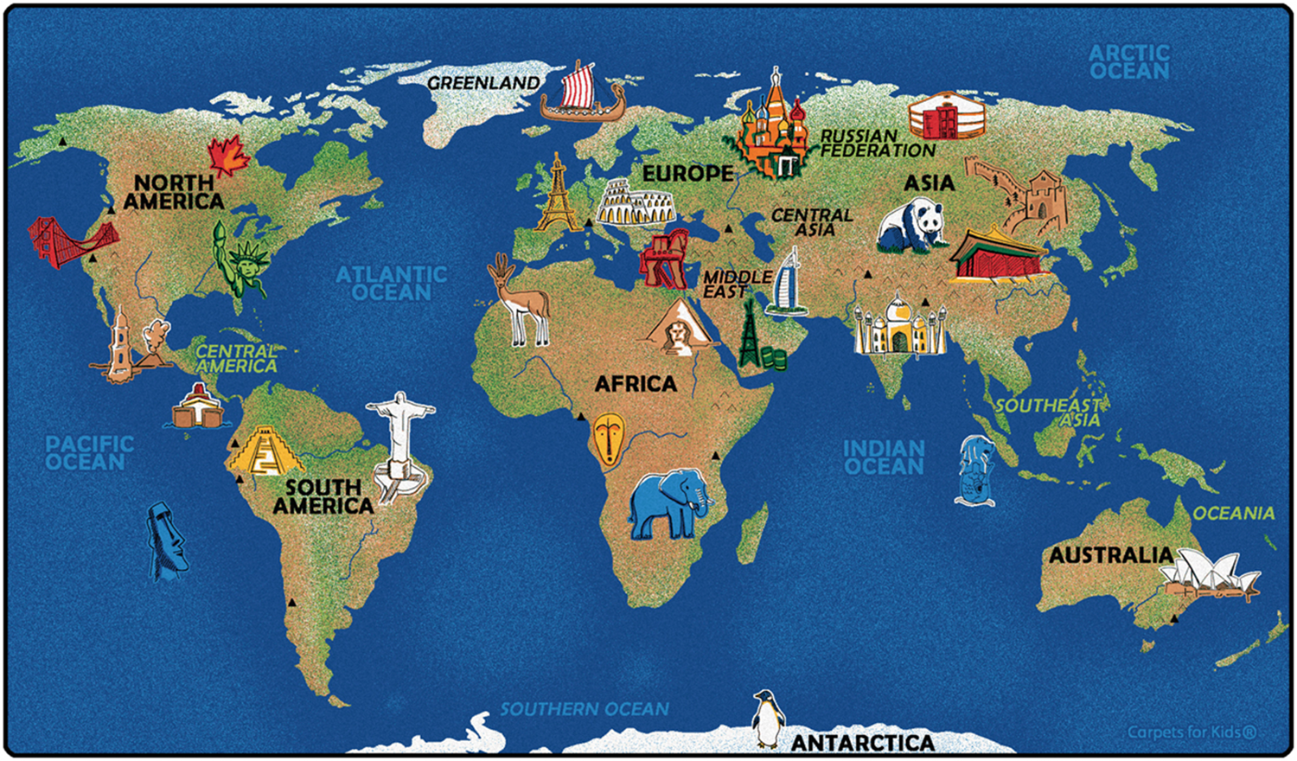
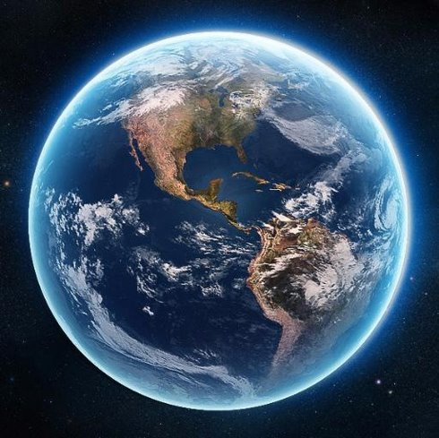
Natural Wonders of the World
- Art@stmatthias

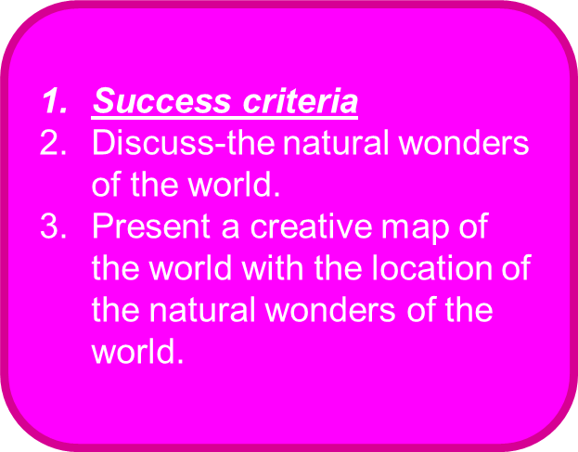
- Grand Canyon — North America​

- Great Barrier Reef — Oceania/Australia​

- Harbor of Rio de Janeiro — South America​

- Mount Everest — Asia​

- Aurora — North America​

- Parícutin Volcano — South America​

- Victoria Falls — Africa

- TASK 1 Using the internet, research and record facts on each of the 7 Natural Wonders of the World
Paricutin Volcano

Victoria Falls


Harbour of Rio de Janerio

Grand Canyon

Aurora

Mount Everest

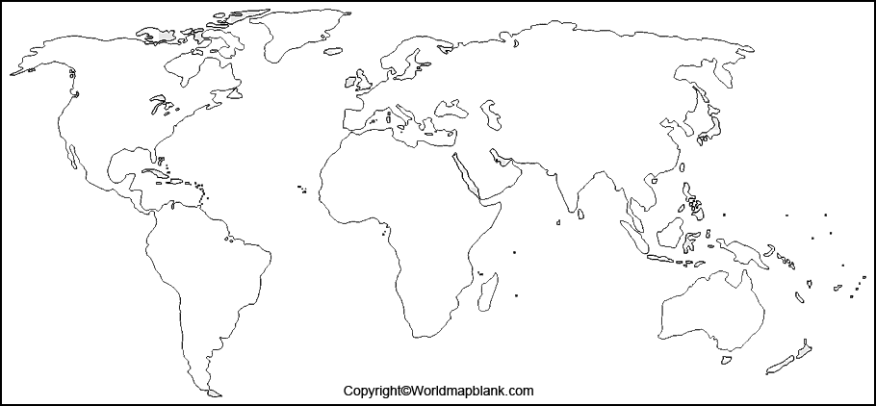
TASK
- DESIGN a creative title: NATURAL WONDERS OF THE WORLD.
DRAW or trace a map of the world.
- LOCATE and MARK the Natural Wonders of the World on the map. Add colour and designs to mark the Wonders of the World.



