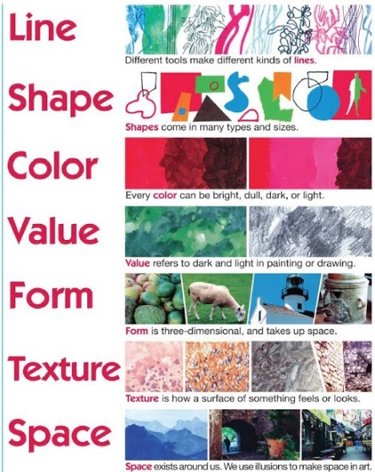
Life and Death
Colour
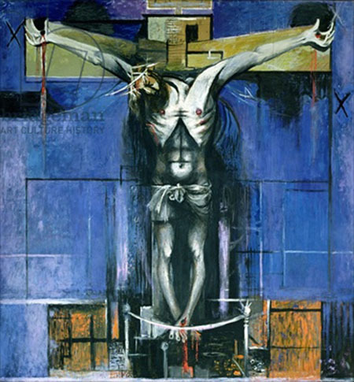
art@stmatthias
The Crucifixion, 1946 (oil on hardboard) by Sutherland, Graham
Discuss the above artwork. What is the subject matter, style, colours used, mood created etc? How are formal elements are used?

For most religious people, belief in life after death is based on teachings in their scriptures or traditions.
TASK-using the internet, find out the meaning for the following:
Word | Definition
Purgatory
Hell
Heaven
Afterlife
Reincarnation
Soul
Materialism
Dualism
Resurrection
Easter Sunday
Good Friday
Saviour
Messiah
Karma
Bereavement
Grief
Funeral
Ashes to Ashes
Judgment day
Judgement
Mortal
Immortal
Crucifixion

Choose 3 of the above and in your sketchbooks, draw a design or image that represent he word. You can use any medium you choose on each. Remember that colour can convey a mood or feeling.
E.g
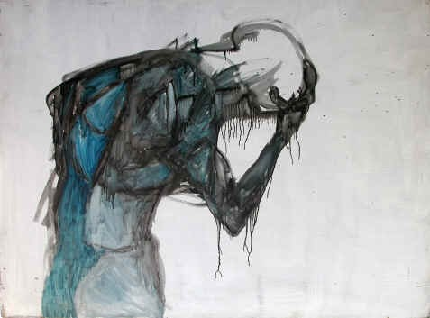 Grief

re-incarnation
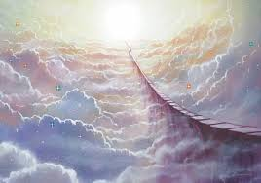
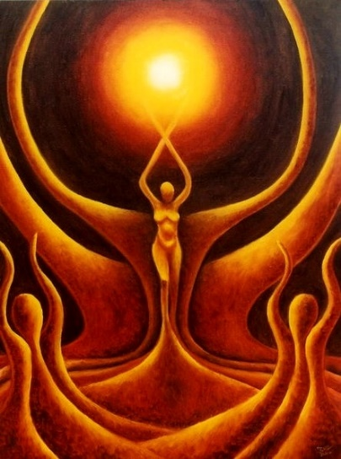
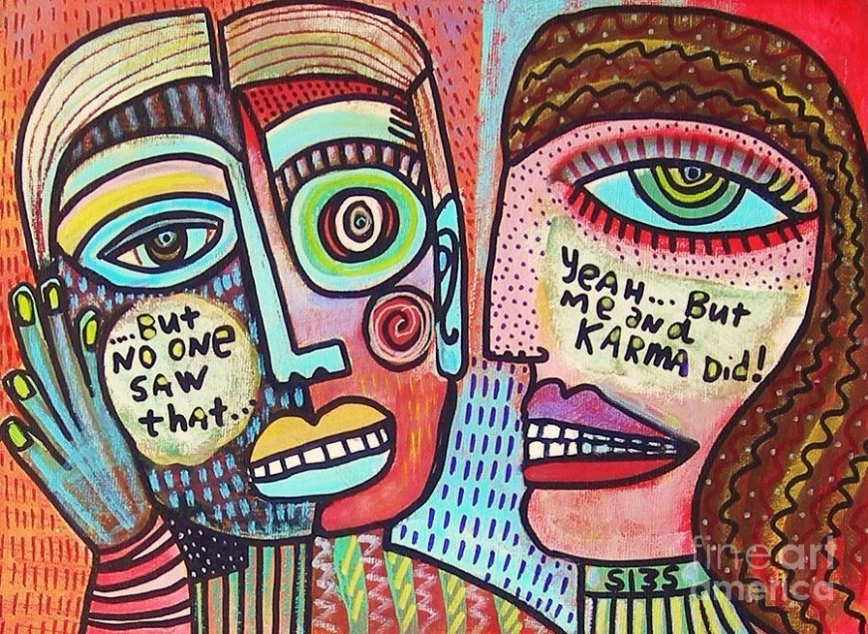
Heaven
Remember to annotate your work.

